**A Neuro-Driven Mobile Robot Enhanced by LoRa and EEG Technology**

**A PROJECT REPORT**

*Submitted By*

|  |  |  |
| --- | --- | --- |
| **AKASH R** | **DSUG20104010** |  |
| **BALAJI M** | **DSUG20104022** |  |
| **BARATH K** | **DSUG20104026** |  |
| **KANNAN S** | **DSUG20104067** |  |

***in partial fulfillment for the award of the degree***

*of*

**BACHELOR OF ENGINEERING**

*in*

**COMPUTER SCIENCE AND ENGINEERING**

**DHANALAKSHMI SRINIVASAN ENGINEERING COLLEGE (AUTONOMOUS)**

**PERAMBALUR – 621 212**

**ANNA UNIVERSITY: CHENNAI 600 025**

**MAY 2024**

**A Neuro-Driven Mobile Robot Enhanced by LoRa and EEG Technology**

**A PROJECT REPORT**

*Submitted By*

|  |  |  |
| --- | --- | --- |
| **AKASH R** | **DSUG20104010** |  |
| **BALAJI M** | **DSUG20104022** |  |
| **BARATH K** | **DSUG20104026** |  |
| **KANNAN S** | **DSUG20104067** |  |

***in partial fulfillment for the award of the degree***

*of*

**BACHELOR OF ENGINEERING**

*in*

**COMPUTER SCIENCE AND ENGINEERING**

**DHANALAKSHMI SRINIVASAN ENGINEERING COLLEGE (AUTONOMOUS)**

**PERAMBALUR – 621 212**

**ANNA UNIVERSITY: CHENNAI 600 025**

**MAY 2024**

**DHANALAKSHMI SRINIVASAN ENGINEERING COLLEGE (AUTONOMOUS)**

**PERAMBALUR – 621 212**

# BONAFIDE CERTIFICATE

Certified that this project report **“A Neuro-Driven Mobile Robot Enhanced by LoRa and EEG Technology”** is the bonafide work of **“AKASH R (DSUG20104010), BALAJI M (DSUG20104022), BARATH K (DSUG20104026), KANNAN S (DSUG20104067)”** who carried out the project work under my supervision.

**SIGNATURE**

**Dr. R. Gopi, M.Tech., Ph.D.,**

**HEAD OF THE DEPARTMENT,**

Department of Computer Science & Engineering,

Dhanalakshmi Srinivasan Engineering College (Autonomous),

Perambalur – 621 212.

**SIGNATURE**

**Mr. K. Aswin, M.E.,**

**SUPERVISOR,**

Department of Computer Science & Engineering,

Dhanalakshmi Srinivasan Engineering College (Autonomous),

Perambalur – 621 212.

Submitted for Project Viva-Voce Examination held on________________

**INTERNAL EXAMINER EXTERNAL EXAMINER**

# ACKNOWLEDGEMENT

We express our gratitude and thanks to **Our Parents** first for giving health and a sound mind for completing this project. We give all the glory and thanks to our almighty **GOD** for showering upon, the necessary wisdom and grace for accomplishing this project.

It is our pleasant duty to express deep sense of gratitude to our honourable Chancellor **Shri. A. Srinivasan**, for his kind encouragement. We have unique pleasure in thanking our Principal **Prof. Dr. D. Shanmugasundaram, M.E., PhD., F.I.E., C.Eng.,** our Dean **Dr. K. Anbarasan**, **M.E., Ph.D.,** and our COE **Dr. K. Velmurugan, M.E., Ph.D.,** for their unflinching devotion, which leads us to complete this project.

We express our faithful and sincere gratitude to our Head of the Department **Dr. R. Gopi, M.Tech., Ph.D.,** for his valuable guidance and support that he gave us during the project time.

We express our faithful and sincere gratitude to our Project Coordinator **Mr. K. Aswin, M.E.,** of Department of Computer Science and Engineering for giving us encouragement and support throughout our project.

We are also thankful to our internal project guide **Mr. K. Aswin, M.E.,** of Department of Computer Science and Engineering for providing valuable guidance and precious suggestions to complete this project successfully.

We render our thanks to all **Faculty members** and **Programmers** of Department of

**Computer Science and Engineering** for their timely assistance.

**DHANALAKSHMI SRINIVASAN ENGINEERING COLLEGE (AUTONOMOUS)**

**DEPARTMENT OF COMPUTER SCIENCE AND ENGINEERING**

**Vision and Mission of the Department:**

**Vision**

To produce globally competent, socially responsible professionals in the field of Computer Science and Engineering.

**Mission**

**M1:** Impart high quality experiential learning to get expertise in modern software tools

**M2:** Inculcate industry exposure and build inter disciplinary research skills.

**M3:** Mould the students to become Software Professionals, Researchers and Entrepreneurs by providing advanced laboratories.

**M4:** Acquire Innovative skills and promote lifelong learning with a sense of societal and ethical responsibilities

**Program Educational Objectives (PEOs)**

**PEO 1:** Graduates of the programme will develop proficiency in identifying, formulating, and resolving complex computing problems.

**PEO 2:** Graduates of the programme will achieve successful careers in the field of computer science and engineering, pursue advanced degrees, or demonstrate entrepreneurial success.

**PEO 3:** Graduates of the programme will cultivate effective communication skills, teamwork abilities, ethical values, and leadership qualities for professional engagement in industry and research organizations.

**ABSTRACT**

The Cognitive Rover project presents an innovative approach to mobile robotics, integrating advanced neuro-technologies with long-range communication capabilities to create a versatile and adaptive robotic platform. The primary objective of the project is to develop a mobile robot capable of autonomous navigation and interaction with its environment, guided by neural signals obtained through electroencephalography (EEG) technology. Leveraging the LoRa (Long Range) communication protocol, the robot establishes robust connectivity over extended distances, enabling remote operation and data transmission in various scenarios, including search and rescue missions, hazardous environment exploration, and remote inspection tasks. The proposed system architecture consists of two main components: a neuro-driven control system and a communication module. The neuro-driven control system utilizes EEG signals collected from a MindWave headset to interpret user commands and environmental stimuli. Through machine learning algorithms and real-time signal processing techniques, the system translates EEG signals into actionable commands for autonomous navigation, obstacle avoidance, and task execution. The communication module integrates LoRa technology to facilitate seamless data exchange between the robot and remote operators, enabling real-time monitoring, control, and video streaming over long distances. Key advantages of the Cognitive Rover include its adaptability to diverse environments, intuitive user interaction through brain-computer interface technology, and robust long-range communication capabilities. Moreover, the project contributes to advancements in robotics, human-robot interaction, and assistive technologies, with potential applications in disaster response, environmental monitoring, and infrastructure inspection.

# TABLE OF CONTENTS

|  |  |  |
| --- | --- | --- |
| **CHAPTER NO** | **TITLE** | **PAGE NO** |
|  | **ABSTRACT** | v |
|  | **LIST OF TABLES** | ix |
|  | **LIST OF FIGURES** | x |
|  | **LIST OF ABBREVIATIONS** | xii |
| **1** | **INTRODUCTION**   * 1. OVERVIEW   2. EEG   3. BRAIN LINK HEADSET   4. BRAIN-COMPUTER INTERFACE   5. OBJECTIVE | 1  1  3  4  4  5 |
| **2** | **LITERATURE SURVEY**   * 1. Arduino Based Bluetooth Voice-Controlled Robot Car and Obstacle Detector   2. Wireless car control system based on ARDUINO UNO R3   3. Wi-Fi Controlled Multi-sensor Robotic Car   4. Car Control by using brain waves and Arduino based Mind wave Mobile   5. BCI based Robotic Arm Control using MI-EEG and Spiking Neural Network   6. Design of Brain Controlled Robotic Car using Raspberry Pi   7. Development of a Cell Phone Based Vehicle Remote Control System   8. Raspberry Pi based Remote Controlled Car using Smartphone Accelerometer   9. A GSM-Based Wireless Remote Controller   2.10 Brain Computer Interface System for Mind Controlled  Robot using Bluetooth | 6  6  7  8  9  10  11  12  13  14  15 |
| **3** | **SYSTEM ANALYSIS**   * 1. EXISTING SYSTEM      1. Disadvantages   2. PROPOSED SYSTEM      1. Advantages | 16  16  17  17  18 |
| **4** | **SYSTEM REQUIRMENTS**   * 1. HARDWARE REQUIRMENTS   2. SOFTWARE REQUIRMENTS | 19  19  19 |
| **5** | **SOFTWARE DESCRIPTION**   * 1. LORA WIRELESS TECHNOLOGY   2. BCI   3. MATLAB   4. ARDUINO IDE | 20  20  22  22  23 |
| **6** | **SYSTEM DESIGN**   * 1. SYSTEM ARCHITECTURE   2. PROCESSING PART   3. ROVER PART   4. COMPONENTS REQUIRED | 24  24  24  25  26 |
| **7** | **SYSTEM IMPLEMENTATION**   * 1. MODULE SPECIFICATION   2. MODULE DESCRIPTION      1. Installing The ESP32 and Lora Library in Arduino IDE      2. Brain-Computer Interface (BCI) Implementation      3. Integration of LoRa Communication      4. Neuro-Driven Control System      5. Real-Time Video Streaming | 29  29  29  29  30  31  34  36 |
| **8** | **SYSTEM TESTING**   * 1. TYPES OF TESTING      1. Unit Testing      2. Integration Testing      3. Functional Test      4. System Test      5. White Box Testing      6. Black Box Testing   2. UNIT TESTING      1. Test Strategy and Approach      2. Test Objectives      3. Features to Be Tested   3. INTEGRATION TESTING   4. ACCEPTANCE TESTING | 39  39  39  39  39  40  40  40  41  41  41  41  41  41 |
| **9** | **CONCLUSION AND FUTURE ENHANCEMENT**   * 1. CONCLUSION   2. FUTURE ENHANCEMENT | 42  42  42 |
| **10** | **APPENDICES**  APPENDIX I SOURCE CODE  APPENDIX II SCREENSHOTS  **REFERENCES**  **CONFERENCE CERTIFICATES**  **JOURNAL PUBLICATION** | 43  43  61  64  65  69 |

## LIST OF TABLES

|  |  |  |
| --- | --- | --- |
| **TABLE NO** | **TITLE** | **PAGE NO** |
| 6.1 | Components used in this project | 26 |
| 6.2 | Specifications of ESP32 DEVKIT V1 DOIT | 27 |
| 7.1 | ESP32 to LoRa Interaction Tx and Rx | 33 |

## LIST OF FIGURES

|  |  |  |
| --- | --- | --- |
| **FIG.NO** | **FIGURE NAME** | **PAGE NO** |
| 1.1 | WSN Comparison Graph | 2 |
| 1.2 | Human Brain Signals | 3 |
| 1.3 | Brain-Link Headset | 4 |
| 1.4 | Brain-Computer Interface | 5 |
| 3.1 | Existing workflow | 16 |
| 3.2 | Implemented workflow | 18 |
| 5.1 | Communication protocol and system architecture of LoRaWAN | 20 |
| 5.2 | LoRa Communication stack | 21 |
| 5.3 | Matlab interface | 22 |
| 5.4 | Arduino IDE | 23 |
| 6.1 | Proposed System Architecture | 24 |
| 6.2 | Processing Side | 25 |
| 6.3 | Rover Side | 26 |
| 6.4 | DOIT ESP32 DEVKIT V1 BOARD | 27 |
| 6.5 | LoRa SX1278 RA02 | 28 |
| 6.6 | LoRa Antenna | 28 |
| 7.1 | Brain-Link Headset | 30 |
| 7.2 | LoRa with ESP32 Transmitter and Receiver | 32 |
| 7.3 | Block Diagram of Rover Side | 33 |
| 7.4 | Block Diagram of Processing side | 34 |
| 7.5 | Matlab interface | 35 |
| 7.6 | Signal Filtering | 35 |
| 7.7 | Signal Mapping | 36 |
| 7.8 | Live Streaming | 37 |
| 7.9 | Matlab Signal Processed Interface | 38 |
| 10.1 | Implemented Cognitive Rover | 61 |
| 10.2 | Matlab Signal Processed Interface | 61 |
| 10.3 | Signal Mapping | 62 |
| 10.4 | Human Control Rover using Brain-link Headset | 62 |
| 10.5 | Live Streaming | 63 |

## LIST OF ABBREVIATIONS

|  |  |  |
| --- | --- | --- |
| **WSN** | - | **W**ireless **S**ensor **N**etwork |
| **LoRa** | - | **L**ong **R**ange |
| **BLE** | - | **B**luetooth **L**ow **E**nergy |
| **IOT** | - | **I**nternet **O**f **T**hings |
| **BCI** | - | **B**rain **C**omputer **I**nterface |
| **EEG** |  | **E**lectro **E**ncephalo **G**raphy |
| **Tx** | - | **T**ransmitter |
| **Rx** | - | **R**eceiver |

**CHAPTER 1**

**INTRODUCTION**

## OVERVIEW

In recent years, advancements in cognitive science and robotics have converged to redefine the possibilities of human-machine interaction. The "Cognitive Rover" project emerges at this intersection, aiming to pioneer a novel approach to mobile robotics. By harnessing the power of EEG signals and integrating them with cutting-edge communication technology, the project seeks to develop a mobile robot capable of understanding and responding to human cognitive commands. Traditional methods of robot control often rely on explicit commands or predefined algorithms, limiting their adaptability and responsiveness in dynamic environments. In contrast, neuro-driven control offers a more intuitive and natural means of interaction, allowing users to convey instructions directly from their cognitive states. This project's innovative aspect lies in its integration of EEG-based Brain-Computer Interface (BCI) technology with LoRa communication, enabling seamless interaction between the user and the robot over extended distances. Through this integration, users can remotely control the robot's movements and actions, fostering new possibilities for applications in exploration, surveillance, and assistance.

According to scientists' study; the Electroencephalogram (EEG) of people can reflect his different states more accurately. So in the modern Intelligent Transportation Systems which mainly characters network and information, if the driver's EEG information can be gathered in Real time, we can drive the vehicle according to the instructions from the brain. Electroencephalography (EEG) is an electrophysiological monitoring method to record electrical activity of the brain. If it can be used for controlling a rover we can make a remarkable change in the transportation field. Nowadays brain controlled wheelchairs are available. With a step ahead of that we are revealing the possibilities of EEG in the field of transportation. The rover was created to inspire all disabled people in the society to have confidence to explore independently.

As we know the brain is the major organ of the central nervous system and center for all the body’s voluntary and involuntary activities. One of the major parts of the brain is cerebellum whose main functions are maintenance of posture and the coordination of body movements. In the human body there are several parts and each having its separate movement. Each area of the cerebellum has its separate significance in the body movements. To control movement the brain has several parallel systems of muscle control.

In the brain machine interface technology, the electrical signals from the brain are extracted and processed to run various applications.

As discussed earlier, this system is formed by using wireless technology and we already have a handful of wireless protocols like BLE (Bluetooth Low Energy), Wi-Fi, and cellular, etc. But these technologies are not ideal for IoT sensor nodes, because they needed to transmit information to a long distance without using much power and with low cost. Apart from this LoRa technology plays a vital role in the agriculture sector.

That’s why we are using LoRa technology, which can perform very-long range transmission of data or information at low cost and without an internet connection.

The term LoRa stands for Long Range. It is a wireless radio frequency technology introduced by Sem tech. LoRa is used to transmitting information in both directions to long-distance and typically LoRa can achieve a distance of 15 to 20 km and can work on battery for a year.

In wireless technology solution, BLE works with low power, but cannot send data to long distance. While using LoRa we can achieve high distance communication without an internet connection, thus it overcomes the drawbacks of Wi-Fi and BLE communication.

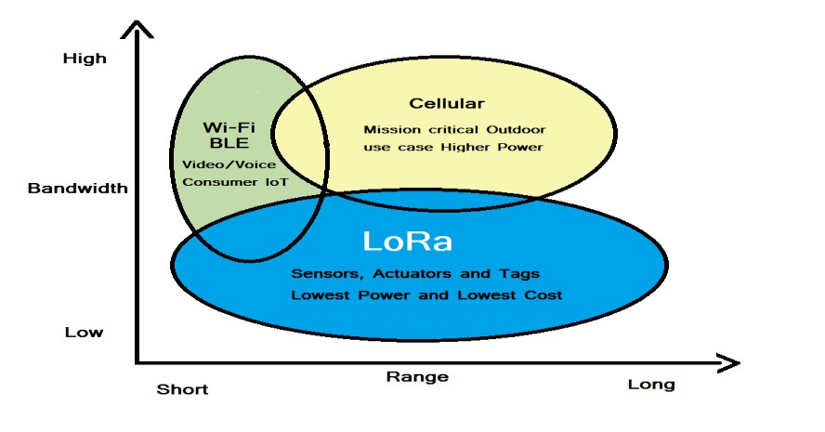The below chart provides a difference between WSN technology.

**Figure 1.1: WSN Comparison Graph**

## EEG

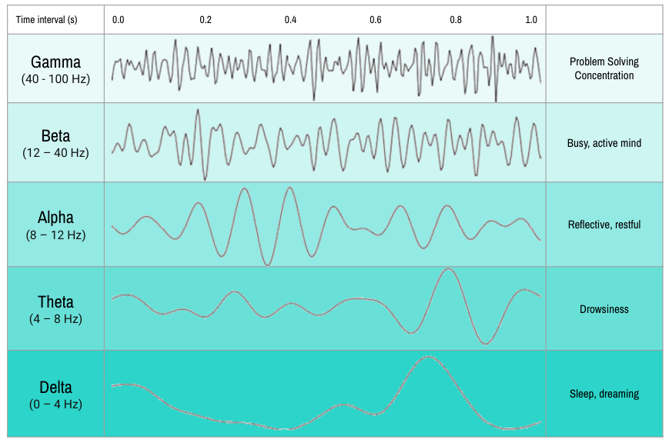Electroencephalography (EEG) is a routine method of medical diagnostics for assessing human brain activity. The electrical signals, induced by activity of the cranial nerves, are measured on the scalp. Thinking consists of a complex interaction of electrical signal processing and chemical signal storage in the brain. Certain parts of the brain are clearly related to activities of the body, e.g. the processing of eye signals used here which takes place in the visual cortex in the back of the human brain. Such electrical processes occur in all parts of the brain and they interfere with each other.

**Figure 1.2: Human Brain Signals**

They can be measured by accompanying voltage on the skin. With the electroencephalography, caps are usually used for applying electrodes which can measure the voltage of a few millionth volts. The signals of normal vision are too complicated and too weak to be used in the EEG. But if a large part of the field of view is occupied by a blinking pattern with a frequency between 8 and 15 Hz, stronger electrical signals of the visual center are induced in the brain. They can be recorded by the EEG, filtered by the computer and processed. Such signals induced by external, defined stimuli are called visually evoked potentials (VEP). The signals are represented as a map (see figure). In medical applications, the doctor makes a diagnosis by comparing the brain activity of the ill person with that of healthy ones.

## BRAIN LINK HEADSET

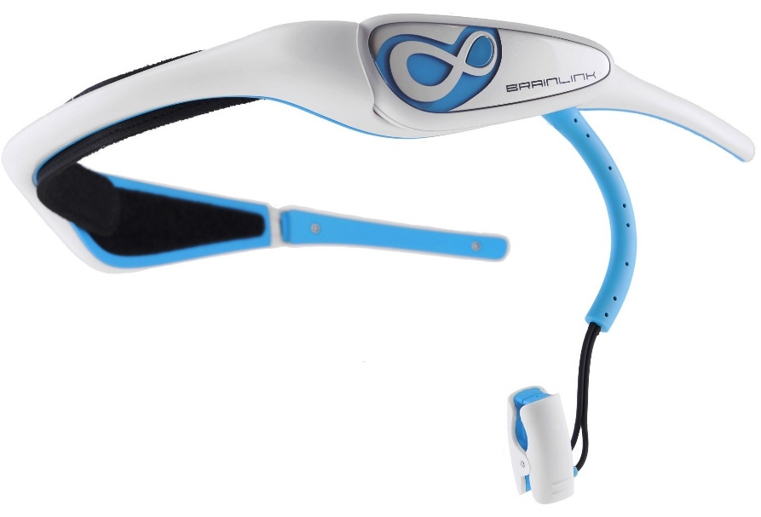It consists of 16 EEG sensors. It measures voltage fluctuations resulting from ionic current flows within the neurons of the brain. The resulting activity is send to the computer for interpretation. These ionic current flows are maintained by neurons which obtain their charge from membrane transport proteins that act as simple pumps transporting ions across the cells membrane. So, the way the headset picks up readings is that when one neuron releases a large amount of ions, these ions can push against other neurons, which push against others and so on. This is known as volume communication, and when that wave reaches the electrodes on the EEG detector, they can exert a force on the metal inside each electrode. This difference in pushing or pulling on the metal between two electrodes is recorded as the EEG reading.

**Figure 1.3: Brain-Link Headset**

## BRAIN-COMPUTER INTERFACE

Sometimes called a mind-machine interface (MMI), direct neural interface (DNI) or brain machine interface (BMI), is a direct communication pathway between a wired brain and an external device. BCIs are often directed at researching, mapping, assisting or repairing human cognitive or sensory-motor functions. A brain computer interface is meant to allow the direct information flow between brain and computer. For the technical implementation, signals from the brain have to be recorded. There are several methods which can be considered for this purpose. The method we use is the relatively cost-effective and simple recording of electrical brain signals (EEG) by means of capacitive electrodes. In our system, the signals of the visual region of the brain are induced by looking at two blinking chequer board patterns on the computer screen.

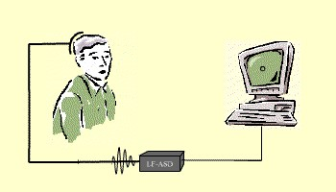If the controlling person concentrates on the blinking pattern on the left side, the vehicle is supposed to drive to the left and accordingly to the right if looking at the pattern on the right side. If none of the chequer board patterns is looked at, the vehicle drives straight ahead. The signals for left and right differ in terms of blinking frequency. Brain-computer interfaces will increase acceptance by offering customized, intelligent help and training, especially for the non-expert user. Development of such a flexible interface paradigm raises several challenges in the areas of machine perception and automatic explanation.

**Figure 1.4: Brain-Computer Interface**

## OBJECTIVE

The project is to develop a mobile robot with neuro-driven control capabilities using EEG signals from a MindWave headset. This entails implementing a Brain-Computer Interface (BCI) for interpreting cognitive states, establishing a robust communication system with LoRa technology, enabling users to control the robot through neuro-driven commands, and integrating a live video feed for remote monitoring.

**CHAPTER 2**

**LITERATURE SURVEY**

* 1. **Title: Arduino Based Bluetooth Voice-Controlled Robot Car and**

**Obstacle Detector**

**Author: Rajeshwari Sissodia, ManMohan Singh Rauthan, Varun**

**Barthwal**

**Published Year: 2023 Publisher: IEEE**

This project aims to develop a robot car controlled via voice commands and equipped with obstacle detection features. By integrating components like the Arduino Uno microcontroller, HC-05 Bluetooth module, and ultrasonic sensor, the system enables users to navigate the robot using verbal instructions. The voice-controlled interface offers hands-free operation, enhancing user convenience and safety. Additionally, the inclusion of obstacle detection technology allows the robot to autonomously avoid collisions, ensuring efficient and reliable navigation. However, challenges such as limited vocabulary recognition and potential signal interference may impact the system's accuracy and reliability.

## Advantages:

* Hands-free operation enhances user convenience and safety.
* Voice-controlled interface offers intuitive and natural interaction.
* Obstacle detection feature improves navigation and collision avoidance.

## Disadvantages:

* Limited vocabulary recognition may restrict the range of voice commands.
* Signal interference or environmental noise can affect voice command accuracy.
* Complexities in system integration and calibration may require technical expertise.
  1. **Title: Wireless car control system based on ARDUINO UNO R3**

**Author: Lang Chen, Jianbo Zhang, Yao Wang**

**Published Year: 2018 Publisher: IEEE**

This project focuses on designing a wireless car control system utilizing the Arduino Uno R3 module. By adopting a modular design approach and leveraging components like ultrasonic sensors, Bluetooth modules, and motor drivers, the system offers flexibility and scalability for various applications. The Arduino Uno R3 serves as a reliable and versatile platform for hardware development, facilitating seamless integration and programming. Wireless communication enables remote control capabilities, enhancing user convenience and operational flexibility. However, potential challenges such as latency issues and signal interference may arise, affecting system performance and reliability.

## Advantages:

* Wireless communication enables remote control capabilities, enhancing flexibility.
* Modular design facilitates scalability and customization for various applications.
* Arduino Uno R3 platform offers versatility and ease of programming.

## Disadvantages:

* Latency issues in wireless communication may impact real-time control.
* Signal interference can affect the reliability of remote control signals.
* Complexity in system setup and configuration may require technical proficiency.
  1. **Title: Wi-Fi Controlled Multi-sensor Robotic Car**

**Author: J.J.Dhanish Kumar, R.Gokul, S.Harshini, G.Nithish**

**Published Year: 2022 Publisher: IEEE**

# 

This project endeavors to create a smartphone-controlled robotic car equipped with Wi-Fi connectivity and multi-sensor capabilities. By utilizing components like Node MCU, Wi-Fi modules, ultrasonic sensors, and temperature sensors, the system enables intuitive control and monitoring via a smartphone application. Smartphone integration offers user-friendly interaction and real-time feedback, enhancing the overall user experience. Wi-Fi connectivity ensures reliable and high-speed communication, enabling seamless operation and data transmission. However, complexities associated with sensor integration and power consumption may pose challenges, impacting system efficiency and cost-effectiveness.

## Advantages:

* Smartphone-controlled interface offers user-friendly interaction and feedback.
* Wi-Fi connectivity enables reliable and high-speed communication.
* Multi-sensor capabilities enhance functionality for diverse applications.

## Disadvantages:

* Power consumption of sensors and communication modules may affect battery life.
* Complexity in sensor integration and calibration may pose challenges.
* Signal interference or network congestion can impact system responsiveness.
  1. **Title: Car Control by using brain waves and Arduino based Mind**

**wave Mobile**

**Author: Khalid Alsammarraie, Timur Inan**

**Published Year: 2022 Publisher: IEEE**

This project explores the utilization of brain waves for controlling a car using an Arduino-based MindWave Mobile interface. By integrating Brain-Computer Interface (BCI) technology with an Android application, the system interprets brainwave signals to execute commands for car movement. Users can control the car through mental commands captured by EEG signals, enhancing accessibility and ease of operation. The combination of brainwave technology and Arduino platform offers a novel and intuitive approach to vehicle control, potentially revolutionizing human-machine interaction. However, challenges related to signal processing and accuracy of EEG interpretation may affect the system's reliability and responsiveness.

## Advantages:

* Brain-computer interface offers a novel and intuitive control interface.
* Integration with Arduino platform facilitates seamless hardware integration.
* Potential for hands-free and intuitive operation enhances user experience.

## Disadvantages:

* Signal processing complexities and accuracy limitations may affect reliability.
* Calibration requirements and user training may be time-consuming.
* Potential for signal interference or noise can impact system performance.
  1. **Title: BCI based Robotic Arm Control using MI-EEG and Spiking**

**Neural Network**

**Author: Joshua Alfred, Harshavardhan S, John Sahaya Rani Alex**

**Published Year: 2022 Publisher: IEEE**

# 

This project focuses on developing a Brain-Computer Interface (BCI) system for controlling a robotic arm using Motor Imagery EEG signals and Spiking Neural Network (SNN) algorithms. By capturing and processing EEG signals associated with motor imagery tasks, the system enables users to manipulate the robotic arm with their thoughts. The integration of SNN technology offers efficient and real-time signal processing, enhancing the system's responsiveness and accuracy. The BCI-based control mechanism provides a natural and intuitive interface for users, enabling precise and dexterous control of the robotic arm. However, challenges such as signal noise and calibration requirements may impact the system's performance and usability.

## Advantages:

* Brain-computer interface offers direct and intuitive control of robotic arm.
* Spiking neural network technology enables efficient signal processing.
* High accuracy and responsiveness enhance precision in robotic arm movements.

## Disadvantages:

* Signal noise and calibration requirements may affect system reliability.
* Complexity in neural network training and optimization may pose challenges.
* Integration with hardware interfaces and real-world applications may require expertise.
  1. **Title: Design of Brain Controlled Robotic Car using Raspberry Pi**

**Author: Enjeti Amareswar, M.Raju Naik, SVS Prasad, N. Vishal**

**Chandra, R. Karthik**

**Published Year: 2021 Publisher: IEEE**

# 

This project aims to develop a brain-controlled robotic car utilizing a Raspberry Pi-based Brain-Computer Interface (BCI). By integrating EEG signal processing with Raspberry Pi, the system enables users to control the car's movement using brainwave patterns. The BCI technology offers a novel and intuitive control interface, allowing users to navigate the robotic car effortlessly. Raspberry Pi serves as a versatile and programmable platform, facilitating seamless integration with EEG sensors and motor control mechanisms. However, challenges related to signal processing algorithms and real-time responsiveness may affect the system's reliability and performance in dynamic environments.

## Advantages:

* Brain-computer interface offers a natural and intuitive control interface.
* Raspberry Pi platform enables flexible and programmable hardware integration.
* Potential for hands-free and independent operation enhances user autonomy.

## Disadvantages:

* Signal processing complexities and real-time responsiveness may affect reliability.
* Calibration requirements and user training may be time-consuming.
* Power consumption and hardware constraints may limit system performance.
  1. **Title: Development of a Cell Phone Based Vehicle Remote Control**

**System**

**Author: Bishwajit Banik Pathik, A.S.M. Ashraf Ahmed, Labina**

**Alamgir, Abu Nayeem**

**Published Year: 2014 Publisher: IEEE**

# 

This project presents the development of a GSM-based remote control system for vehicles using cell phones. By leveraging GSM communication technology, the system enables users to remotely control vehicle functions via simple phone calls. The integration of solar power enables sustainable and autonomous operation, enhancing the system's reliability and energy efficiency. The use of Dual Tone Multiple Frequency (DTMF) tones for command transmission offers a simple and robust control interface, suitable for various applications. However, limitations such as network coverage and latency may affect the system's responsiveness and reliability in remote locations.

## Advantages:

* GSM-based remote control offers ubiquitous connectivity and accessibility.
* Solar-powered operation enhances sustainability and autonomy.
* Simple and robust control interface via DTMF tones enhances user experience.

## Disadvantages:

* Network coverage limitations and latency issues may affect responsiveness.
* Security vulnerabilities in GSM communication may pose risks.
* Complexity in system setup and configuration may require technical expertise.
  1. **Title: Raspberry Pi based Remote Controlled Car using Smartphone**

**Accelerometer**

**Author: Varsha Vishwa Kiran, S Santhanalakshmi**

**Published Year: 2019 Publisher: IEEE**

# 

This project focuses on developing a remote-controlled car using Raspberry Pi and smartphone accelerometer sensors. By establishing Wi-Fi communication between the Raspberry Pi-based car and a smartphone, users can control the vehicle's movement by tilting the phone. The integration of accelerometer, gyrometer, and magnetometer sensors offers intuitive and responsive control, enhancing the user experience. Additionally, the inclusion of a Pi camera enables remote surveillance and navigation capabilities, expanding the car's functionality. However, challenges such as sensor calibration and network latency may impact the system's responsiveness and performance.

## Advantages:

* Smartphone-controlled interface offers intuitive and responsive interaction.
* Wi-Fi communication enables seamless control and monitoring from anywhere.
* Integration with sensors and camera enhances functionality for surveillance and navigation.

## Disadvantages:

* Sensor calibration and network latency may affect real-time responsiveness.
* Power consumption and battery life limitations may impact usability.
* Complexity in setup and configuration may require technical proficiency.
  1. **Title: A GSM-Based Wireless Remote Controller**

**Author: Gang Cao, Tiefeng Xu, Taijun Liu, Yan Ye, Gaoming Xu**

**Published Year: 2011 Publisher: IEEE**

# 

This project introduces a GSM-based wireless remote power controller for home automation applications. By utilizing GSM communication modules, the system enables users to remotely control household appliances from anywhere using mobile phones. The integration of GSM technology offers reliable and ubiquitous connectivity, ensuring seamless operation and accessibility. The modular design and implementation of remote-control modules enhance the system's flexibility and scalability for diverse applications. However, challenges such as network congestion and security vulnerabilities may affect the system's reliability and privacy.

## Advantages:

* GSM-based remote control offers widespread coverage and accessibility.
* Modular design enables flexibility and scalability for diverse applications.
* Simple and reliable control interface via GSM communication enhances usability.

## Disadvantages:

* Network congestion and latency issues may affect responsiveness.
* Security vulnerabilities in GSM communication may pose risks.
* Complexity in system integration and configuration may require technical expertise.
  1. **Title: Brain Computer Interface System for Mind Controlled Robot**

**using Bluetooth**

**Author: Siliveru Ramesh, M.Gopi Krishna, Madhu Nakirekanti**

**Published Year: 2014 Publisher: IJCA**

# 

This project proposes a Brain-Computer Interface (BCI) system for controlling a robot using mind-controlled commands transmitted via Bluetooth. By analyzing brainwave signals using LabVIEW software, the system interprets user intentions and translates them into robot movements. The BCI technology offers a direct and intuitive control interface, allowing users to interact with the robot effortlessly. Bluetooth connectivity enables wireless communication between the brainwave analysis system and the robot, facilitating seamless integration and operation. However, challenges such as signal processing complexity and calibration requirements may affect the system's accuracy and responsiveness.

## Advantages:

* Brain-computer interface offers direct and intuitive control of the robot.
* Bluetooth connectivity enables wireless communication and flexibility in operation.
* Integration with LabVIEW software facilitates signal analysis and real-time control.

## Disadvantages:

* Signal processing complexities and calibration requirements may affect accuracy.
* Bluetooth range limitations and interference may impact wireless communication.
* Integration with hardware components and user training may require expertise.

**CHAPTER 3**

**SYSTEM ANALYSIS**

# 3.1 EXISTING SYSTEM

The integration of cognitive science, robotics, and long-range communication technology for neuro-driven mobile robots was limited. Existing systems predominantly relied on simpler control mechanisms, such as manual remote control or pre-programmed algorithms, lacking direct integration with human cognitive states. EEG-based Brain-Computer Interfaces (BCIs) were still in their infancy, primarily used in research settings rather than practical applications. Communication technologies for remote robot control were often limited to short-range options like Wi-Fi or Bluetooth, restricting the robot's operational range. Live video streaming from robots for remote monitoring was also less common, with limited bandwidth and connectivity options hindering real-time data transmission.

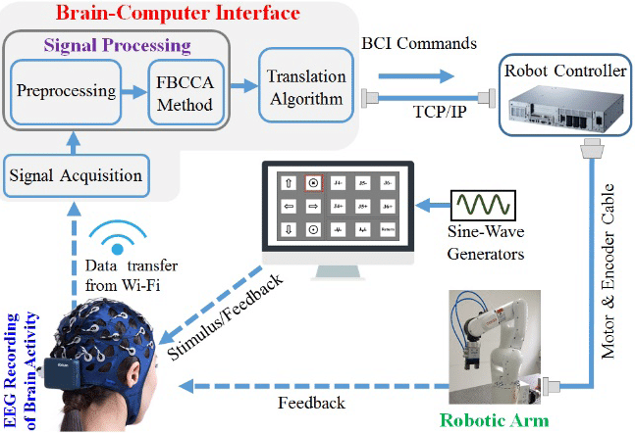

**Figure 3.1: Existing workflow**

## 3.1.1 DISADVANTAGES

* **Limited autonomy:** Reliance on manual remote control or pre-programmed algorithms restricts the robot's ability to adapt to dynamic environments without human intervention.
* **Lack of direct human-robot interaction:** Absence of EEG-based Brain-Computer Interfaces (BCIs) means that the robot cannot interpret human cognitive commands directly, limiting the scope of interaction and user experience.
* **Restricted operational range:** Dependence on short-range communication technologies like Wi-Fi or Bluetooth confines the robot's mobility and operational capabilities to within a limited distance from the user.
* **Inadequate remote monitoring:** Limited options for live video streaming hinder real-time monitoring of the robot's surroundings, reducing situational awareness and responsiveness in remote operation scenarios.
* **Limited scalability:** The lack of advanced integration between cognitive science, robotics, and communication technology impedes the development of more sophisticated and adaptable mobile robot systems.

# 

# PROPOSED SYSTEM

The proposed system introduces a paradigm shift in mobile robotics by integrating cognitive science, robotics, long-range communication technology. It features a Brain-Computer Interface (BCI) that interprets cognitive states from EEG signals obtained through a MindWave headset, enabling direct human-robot interaction. MATLAB facilitates the interface between the BCI sensor and the laptop, allowing for seamless data processing and analysis. Communication between the robot and a user interface is facilitated by LoRa technology, ensuring efficient data transfer over extended distances. Users can control the robot's movements and actions through neuro-driven commands derived from EEG signals processed in MATLAB. This comprehensive system aims to revolutionize human-robot interaction capabilities, paving the way for applications in exploration, surveillance, and assistance.

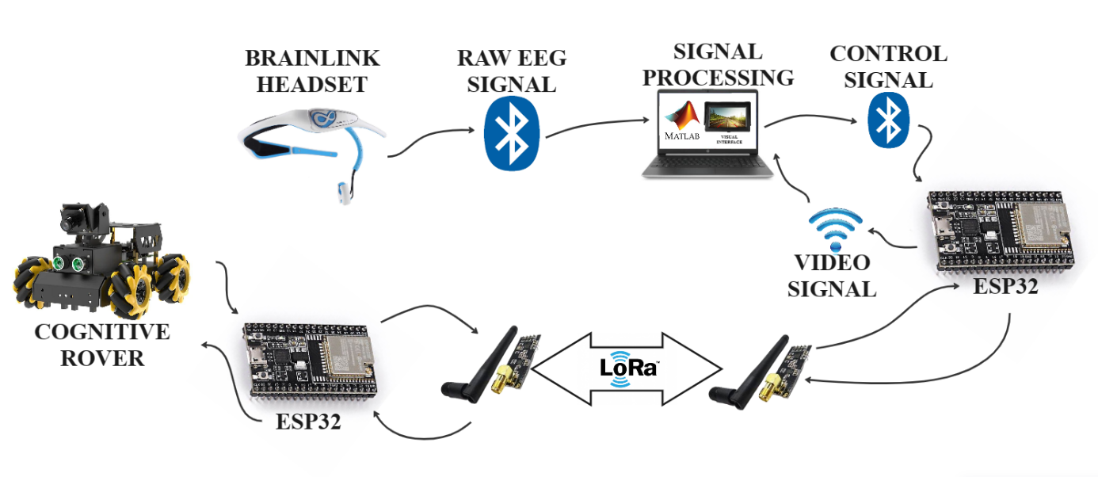

**Figure 3.2 Implemented workflow**

## 3.2.1 ADVANTAGES

* **Enhanced human-robot interaction:** The integration of EEG-based Brain-Computer Interface (BCI) technology enables direct interpretation of human cognitive commands, leading to more intuitive and natural interaction.
* **Extended operational range:** Utilization of LoRa technology allows for efficient and reliable data transfer over long distances, expanding the robot's operational capabilities beyond the limitations of short-range communication technologies.
* **Improved autonomy:** Neuro-driven control enables the robot to make decisions based on real-time cognitive states, enhancing its ability to navigate and interact autonomously in dynamic environments.
* **Enhanced remote monitoring:** Integration of a live video feed through the robot's camera enables real-time monitoring of its surroundings, providing users with greater situational awareness and control in remote operation scenarios.
* **Versatile applications:** The comprehensive integration of cognitive science, robotics, and communication technology opens up new possibilities for applications in exploration, surveillance, assistance, and other fields where human-robot interaction is crucial.

**CHAPTER 4**

**SYSTEM REQUIRMENTS**

* 1. **HARDWARE REQUIRMENTS**
* CPU type: Intel Pentium 4
* Clock speed: 3.0 GHz
* Ram size: 2 GB
* Hard disk capacity: 40 GB
* Monitor type: 15 Inch color monitor
* Keyboard type: internet keyboard
* Microcontroller
* BCI Sensor
* Lora Module
* Motor Driver
* Dc Motor
* 9v Battery
  1. **SOFTWARE REQUIRMENTS**
* Operating System: Windows OS
* Language: Embedded C, Matlab
* IDE: Visual Studio Code, Arduino IDE, Matlab IDE
* Application: Windows Application

**CHAPTER 5**

**SOFTWARE DESCRIPTION**

* 1. **LoRa WIRELESS TECHNOLOGY**

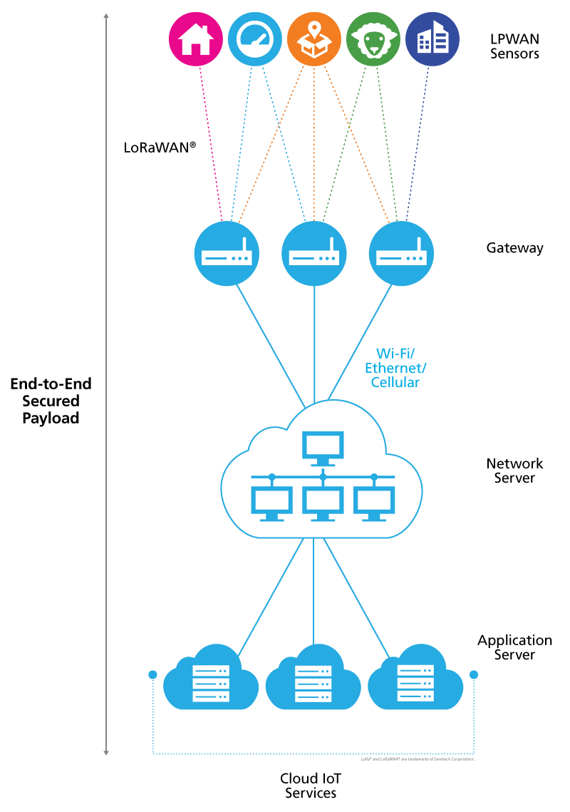In this section, the basic concepts of LoRaWAN, LPWAN, and LoRa technologies will be described. Figure 5.1, characterizes typical parts and architecture of an LPWAN network. The LPWAN sensors, or an end node, collect different measured values and using LoRaWAN to send the data to the gateway. The gateway transmits the data to some internet cloud service. The client can use that collected data from cloud services. The advantage of LoRa lies in technology’s long-range capability. A single base station can cover hundreds of square kilometers, but the range is highly dependent on the environment or obstructions. The LoRa modulation can be utilized by many different protocol architectures such as Star, and Mesh.

**Figure 5.1: Communication protocol and system architecture of LoRaWAN**

LoRaWAN ensures data rates from 0.3 kbps up to 50 kbps, which are considered acceptable for transmitting real-time sensor data in the IoT. The bandwidth of LoRa is low, nonetheless, transmitting anything that requires high bandwidth, or transmission of real-time image data, that may not suitable on the LoRa network.

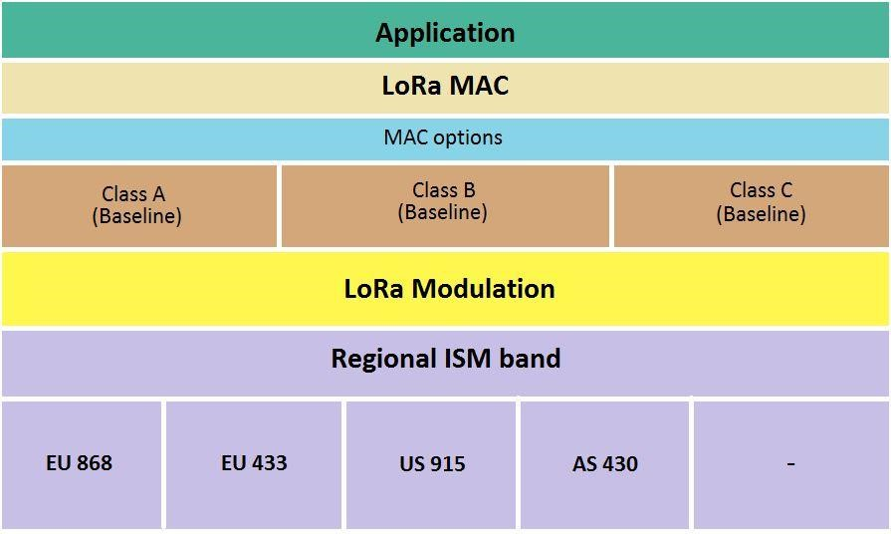LoRaWAN defines three classes of devices. These device classes can negotiate network downlink communication latency versus the battery lifetime. These classes are shown in Fig. 3.9 and, depending on the application needs, A, B, or C class can be chosen. Battery-powered devices in “Class A” are intended for low powered devices such as sensors, these are the most energy-efficient class but have the biggest latency time. It also includes devices that do not need to transmit data all the time. All the LoRaWAN-capable devices must support the functionalities of this class. Class B is focused on battery-powered devices such as sensors. These are energy efficient but with a latency controlled downlink. And the C class is used by bi-directional (both direction) with maximal receive slots, which has almost continuously open receive windows, which are only closed when transmitting.

**Figure 5.2: LoRa Communication stack**

LoRaWAN network protocol security is based on IEEE 802.15.4 and is also extended by using two session keys: a network session key and an application session key. Each LoRaWAN edge node device also has its own 128-bit AES key, known as the AppKey.

# 5.2 BCI

A brain–computer interface (BCI), sometimes called a brain–machine interface (BMI) or smartbrain, is a direct communication pathway between the brain's electrical activity and an external device, most commonly a computer or robotic limb. BCIs are often directed at researching, mapping, assisting, augmenting, or repairing human cognitive or sensory-motor functions. They are often conceptualized as a human–machine interface that skips the intermediary component of the physical movement of body parts, although they also raise the possibility of the erasure of the discreteness of brain and machine. Implementations of BCIs range from non-invasive (EEG, MEG, MRI) and partially invasive (ECoG and endovascular) to invasive (microelectrode array), based on how close electrodes get to brain tissue.

# 5.3 MATLAB

MATLAB stands for Matrix Laboratory. It is a high-performance language that is used for technical computing. It was developed by Cleve Molar of the company MathWorks.Inc in the year 1984.It is written in C, C++, Java. It allows matrix manipulations, plotting of functions, implementation of algorithms and creation of user interfaces.

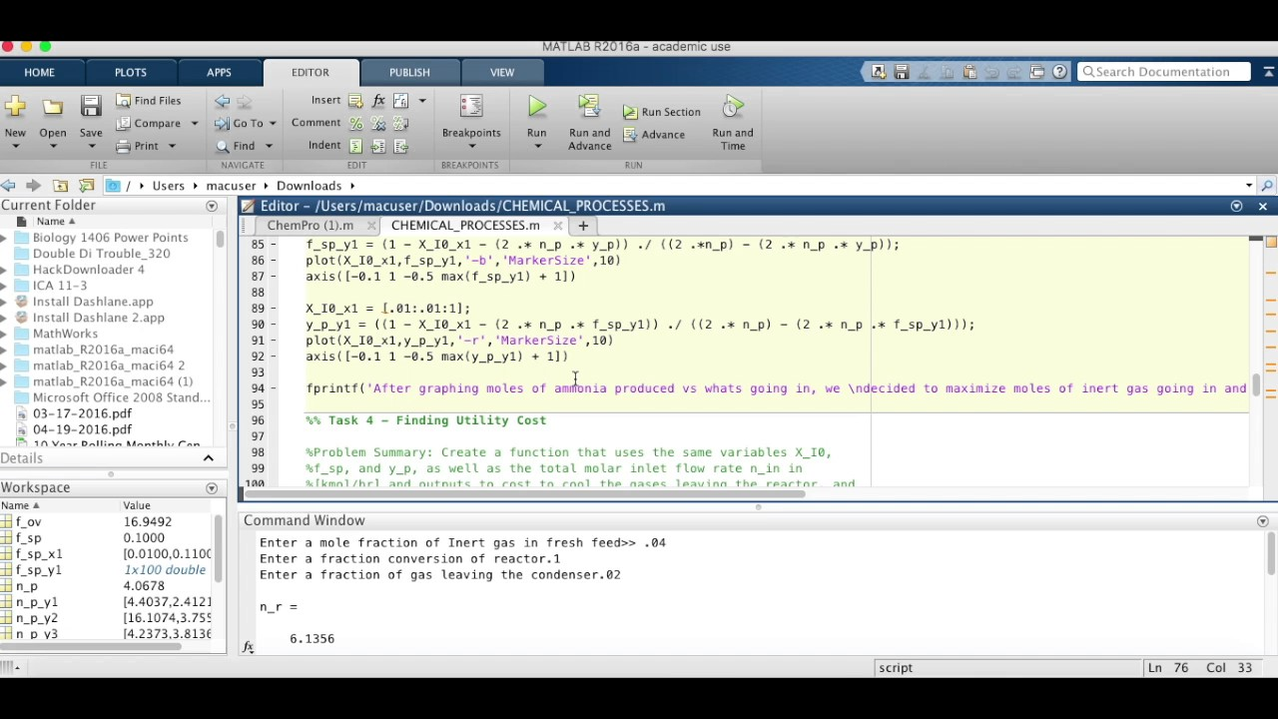

**Figure 5.3: Matlab interface**

# 5.4 ARDUINO IDE

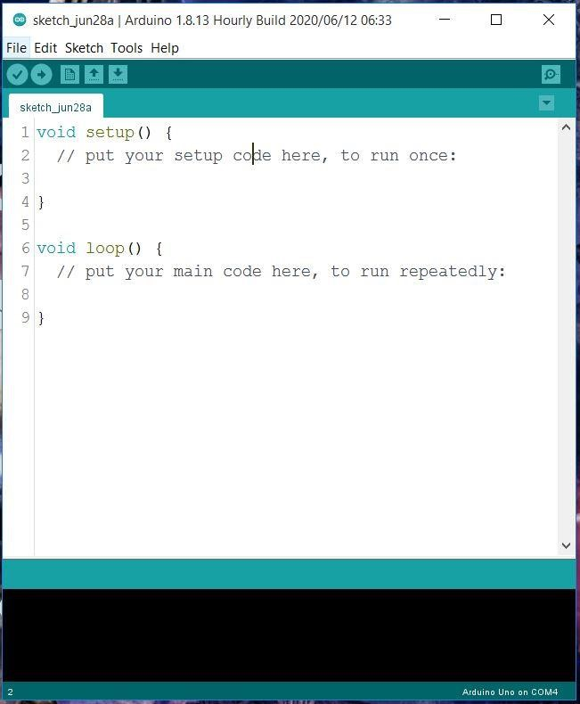The Arduino Integrated Development Environment (IDE) encompasses a text editor for writing code, it connects to the Arduino and Genuino hardware to upload programs and transmit with them. The programs are written using IDE are knows as sketches. And the file extension of the program is “.ino”. Like other editors, Arduino IDE has also featured for cutting/pasting and for searching/replacing text. The console of IDE provide error messages and other information, and the bottom right-hand corner of the window displays the configured board and serial port. The toolbar buttons allow you to verify and upload programs, create, open, and save sketches, and open the serial monitor.

**Figure 5.4: Arduino IDE**

**CHAPTER 6**

**SYSTEM DESIGN**

* 1. **SYSTEM ARCHITECTURE**

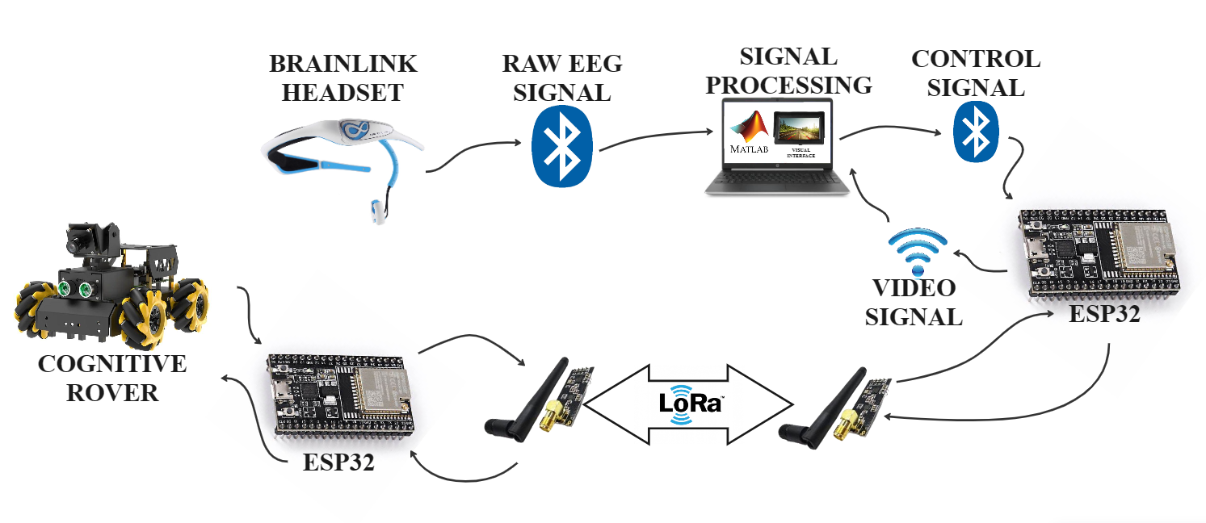

**Figure 6.1: Proposed System Architecture**

The block diagram of the project consists of two main parts: the transmitter and the receiver. In the transmitter part, the Brain-Computer Interface (BCI) sensor communicates with a laptop via Bluetooth, while the laptop interfaces with a microcontroller. The microcontroller is connected to a LoRa transmitter for long-range communication. In the receiver part, a LoRa receiver receives signals from the transmitter and communicates with another microcontroller. The output section of the receiver includes a motor driver connected to two DC motors powered by a battery. This setup enables the transmission of cognitive commands from the BCI sensor to the robot via long-range communication, allowing for remote control of the robot's movements and actions.

* 1. **PROCESSING PART**

The processing component of the Cognitive Rover project serves as the brain's interface with the robotic system. At its core lies the Brain-Computer Interface (BCI) sensor, which captures and interprets brainwave signals indicative of the user's intentions and commands. These signals are wirelessly transmitted to a laptop via Bluetooth connectivity, where sophisticated algorithms and signal processing techniques decode them into actionable instructions for the robot.

This intermediary processing stage ensures that the user's cognitive commands are accurately translated into control signals, laying the groundwork for precise robotic action.

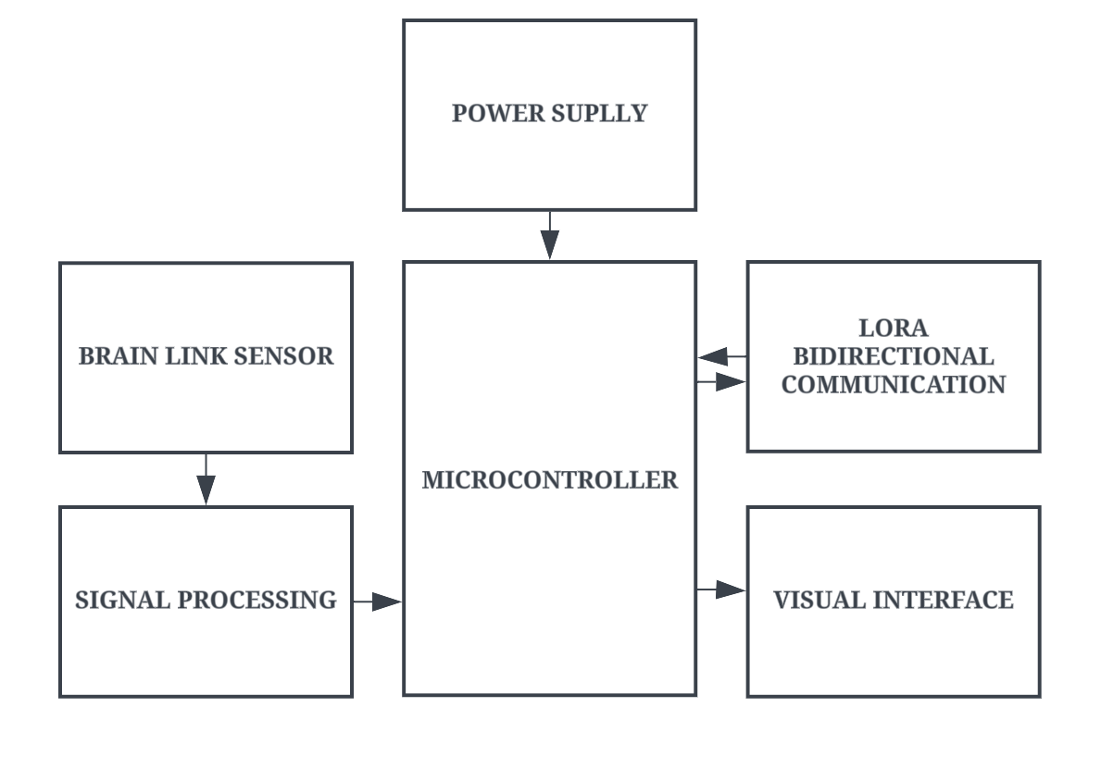

**Figure 6.2: Processing Side**

* 1. **ROVER PART**

The rover component of the system serves as the executor of the transmitted commands, translating digital signals into physical motion. Upon receiving the processed commands from the transmitter via a LoRa receiver module, a dedicated microcontroller within the receiver circuitry deciphers and interprets them.

This microcontroller acts as the central processing unit of the robot, orchestrating the activation of motor drivers responsible for controlling the movement of the robot's locomotive components. By meticulously coordinating the activation of these motor drivers, the receiver section brings the user's cognitive instructions to life, enabling the robot to navigate its environment autonomously and responsively.

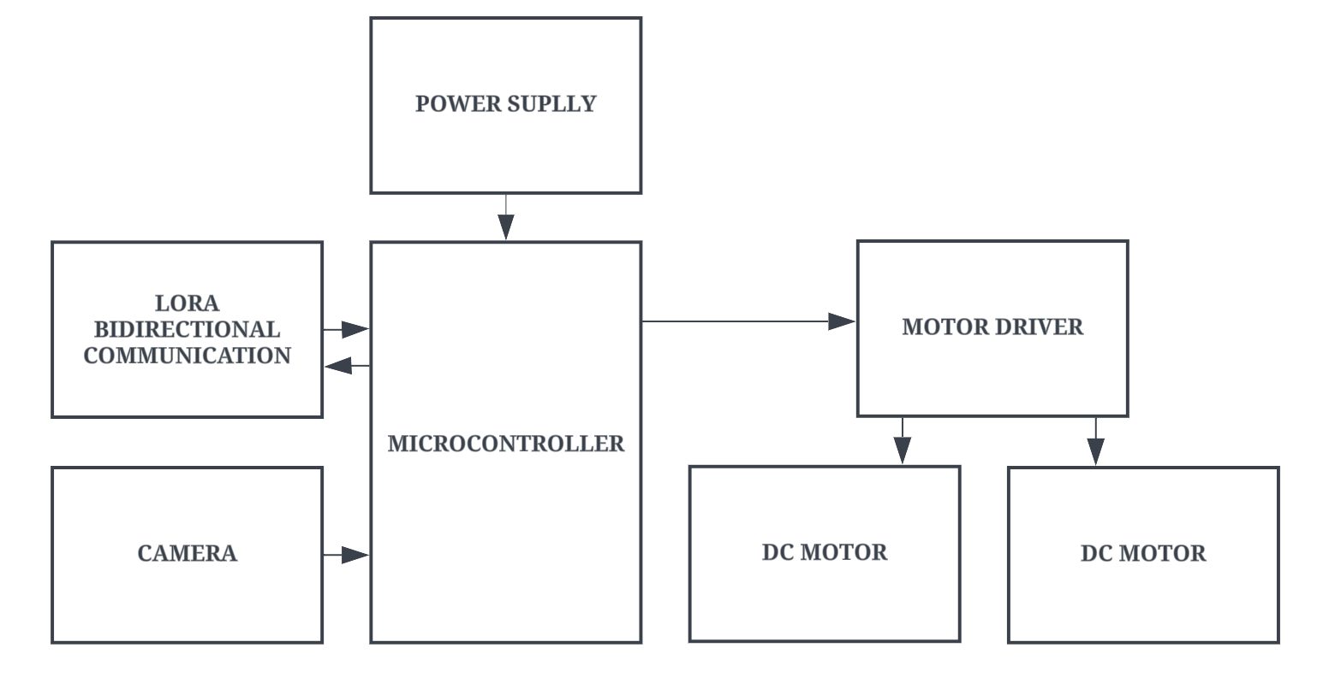**Figure 6.3: Rover Side**

* 1. **COMPONENTS REQUIRED**

**Table 6.1 Components used in this project**

|  |  |  |
| --- | --- | --- |
| **S.NO** | **COMPONENT** | **QUANTITY** |
| 1. | DOIT ESP32 DEVKIT V1 BOARD | 2 |
| 2. | LoRa SX1278 RA02 | 2 |
| 3. | LoRa ANTENNA | 2 |
| 4. | ESP32-CAM | 1 |
| 5. | DC Motors | 4 |
| 6. | Tires | 4 |
| 7. | L298N Motor Controller | 1 |
| 8. | Brainlink EEG BCI Headset | 1 |

* + 1. **DOIT ESP32 DEVKIT V1 BOARD**

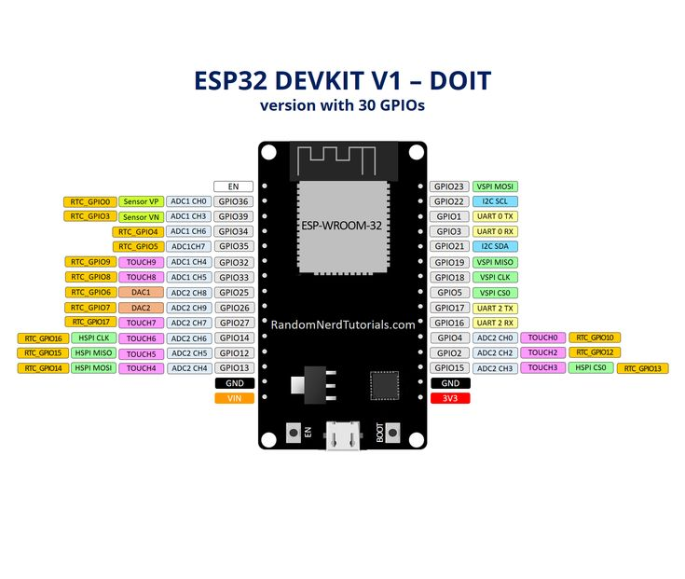The ESP32 is a series of chip microcontrollers developed by Espressif.

**Figure 6.4: DOIT ESP32 DEVKIT V1 BOARD**

**Table 6.2 Specifications of ESP32 DEVKIT V1 DOIT**

|  |  |
| --- | --- |
| **Number of cores** | 2 (dual core) |
| **Wi-Fi** | 2.4 GHz up to 150 Mb/s |
| **Bluetooth** | BLE (Bluetooth Low Energy) and legacy Bluetooth |
| **Architecture** | 32 bits |
| **Clock frequency** | Up to 240 MHz |
| **RAM** | 512 KB |
| **Pins** | 30, 36, or 38 (depending on the model) |
| **Peripherals** | Capacitive touch, ADC (analog to digital converter), DAC (digital to analog converter), I2C (Inter-Integrated Circuit), UART (universal asynchronous receiver/transmitter), CAN 2.0 (Controller Area Netwokr), SPI (Serial Peripheral Interface), I2S (Integrated Inter-IC Sound), and more. |

* + 1. **LoRa SX1278 RA02**

The LoRa SX1278 RA02 works with SPI communication protocol so it can be used with any micro microcontroller that supports SPI communication protocol. It is mandatory to use an antenna along with the module else it might damage the module permanently. The module should be powered only with 3.3V, and the operating voltage is 3.3V, and the frequency is 433 MHz and transmits and receives packets up to 256 bytes. Here we are not legally allowed to use the 433MHz frequency module for a long time other than for educational purposes.

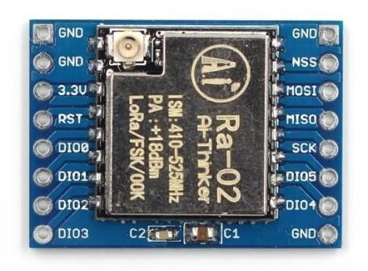

**Figure 6.5: LoRa SX1278 RA02**

* + 1. **LoRa ANTENNA**

Using the LoRa or Sigfox connectivity on the LoPy4 you are going to need to connect a special antenna before beforehand otherwise you risk damaging the device. This universal LoRa and Sigfox Antenna Kit can also be used with LoPy, SiPy, and FiPy IoT development boards on top of the LoPy4.

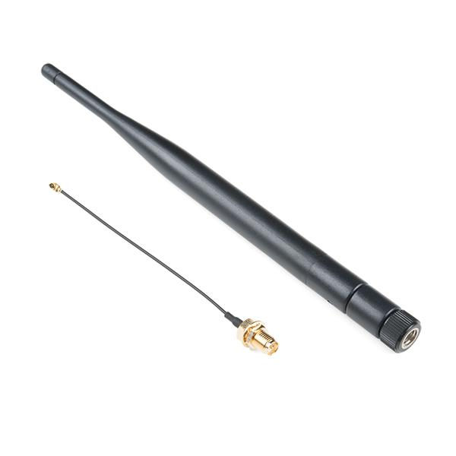

**Figure 6.6: LoRa Antenna**

**CHAPTER 7**

**SYSTEM IMPLEMENTATION**

* 1. **MODULE SPECIFICATION**
* Installing The ESP32 and Lora Library in Arduino IDE
* Brain-Computer Interface (BCI) Implementation
* Integration of LoRa Communication
* Neuro-Driven Control System
* Real-Time Video Streaming
  1. **MODULE DESCRIPTION**

The project integrates various modules to create a comprehensive cognitive rover system. The Brain-Computer Interface (BCI) Implementation module enables direct communication between the user's brain signals and the robot's control system, facilitating intuitive control. Integration of LoRa Communication establishes long-range wireless communication between the robot and the operator, ensuring reliable data transmission over extended distances. The Neuro-Driven Control System harnesses advanced algorithms to interpret brain signals and translate them into precise commands for controlling the robot's movements and actions. Additionally, Real-Time Video Streaming utilizes the ESP32-CAM to transmit live video feed from the robot's camera, providing operators with visual feedback for remote monitoring and surveillance. Together, these modules enable seamless interaction and control of the cognitive rover system, enhancing its functionality and usability in various applications.

* + 1. **Installing The ESP32 and Lora Library In Arduino IDE**

In the first step, we are going to do some basic interaction between LoRa and ESP32. For doing that we require a number of two ESP32, and two LoRa RA02 SX1278 modules. There is mandatory to operate the LoRa module with antenna, else output power will damage the module. Here we are using a 433Mhz LoRa module, so my antenna is also rated for 433Mhz. For doing this interaction, we need to create one transmitter and one receiver.

**Installing the ESP32 in Arduino IDE**

To be able to program the ESP32 using Arduino IDE, you need to add support for the ESP32 boards. Follow the next steps:

**Go to File > Preferences.**

Enter the following into the “Additional Board Manager URLs” field. This will add support for ESP32 and ESP8266 boards as well.

**https://raw.githubusercontent.com/espressif/arduino-esp32/gh-pages/package_esp32_ index.json,http://arduino.esp8266.com/stable/package_esp8266com_index.json**

**Open the Boards Manager. Go to Tools > Board >Boards Manager…**

Search for ESP32 and install the “ESP32 by Espressif Systems “: That’s it. It will be installed after a few seconds.

After this, restart your Arduino IDE.

**Then, go to Tools > Board and check that you have ESP32 boards available.**

Now, you’re ready to start programming your ESP32 using Arduino IDE.

* + 1. **Brain-Computer Interface (BCI) Implementation**

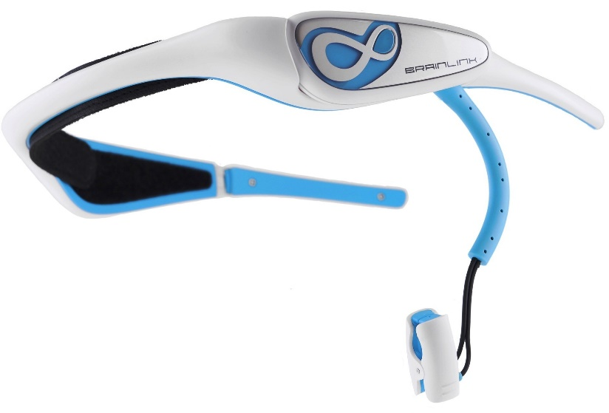The Brain-Computer Interface (BCI) Implementation module integrates sensors capable of capturing brainwave signals directly from the user's brain. These sensors, often EEG (Electroencephalography) devices, detect electrical activity generated by neurons in the brain and convert it into digital signals.

**Figure 7.1: Brain-Link Headset**

Advanced signal processing techniques, including filtering and feature extraction algorithms, are employed to preprocess the raw brainwave data, enhancing its quality and reliability. Machine learning algorithms, such as neural networks or support vector machines, are then utilized to interpret the processed signals and classify them into distinct mental states or commands. This enables the system to recognize specific brain patterns associated with user intentions, such as movement commands or cognitive tasks.

The BCI system establishes a direct communication pathway between the user's brain and the robot, allowing for seamless interaction without the need for traditional input devices. Users can control the robot's actions simply by modulating their brain activity, such as imagining specific movements or focusing on particular tasks. Real-time feedback mechanisms ensure that the system continuously adapts to the user's cognitive state, providing a responsive and intuitive control experience. Moreover, the BCI implementation is designed to be user-friendly and accessible, accommodating individuals with varying levels of cognitive ability or motor function. This fosters inclusivity and enables a wide range of users to engage with the robot effectively.

By harnessing the power of brainwave signals, the BCI implementation module unlocks new possibilities for human-robot interaction and control. It enables intuitive and natural communication between users and robots, enhancing the usability and accessibility of robotic systems in diverse applications. Additionally, ongoing research and development efforts in BCI technology continue to improve signal processing algorithms, classification accuracy, and system robustness, further advancing the capabilities and performance of BCI-enabled robots. As a result, the BCI implementation module represents a crucial component in creating intelligent and user-centric robotic systems that can seamlessly integrate into various environments and assist users in accomplishing tasks more efficiently and effectively.

* + 1. **Integration of LoRa Communication**

In the Integration of LoRa Communication module, there are two distinct components: the transmitter and the receiver. The transmitter is responsible for sending data from the robot to the user interface, while the receiver receives data from the user interface and relays commands or feedback to the robot.

 The transmitter part of the LoRa Communication module is integrated into the robot's hardware architecture. It consists of a LoRa transceiver module connected to the microcontroller onboard the robot. This module is programmed to encode data packets containing information about the robot's status, sensor readings, or telemetry data. The LoRa transceiver employs modulation techniques to transmit these packets wirelessly over long distances, ensuring reliable communication with the receiver.

**Figure 7.2: LoRa with ESP32 Transmitter and Receiver**

On the user interface side, the receiver part of the LoRa Communication module is integrated into the hardware or software interface used to control or monitor the robot. It consists of another LoRa transceiver module connected to a microcontroller or a computer. This module is configured to receive the data packets transmitted by the robot's transmitter. Upon receiving the packets, the receiver decodes the information and processes it accordingly. For example, if the data packet contains commands for the robot, the receiver forwards these commands to the appropriate components of the robot's control system.

**Table 7.1 ESP32 to LoRa Interaction Tx and Rx**

|  |  |
| --- | --- |
| **LoRa SX1278 Module** | **ESP32 Board** |
| VCC | 3.3V |
| Gnd | Ground |
| MOSI | GPIO 23 |
| MISO | GPIO 19 |
| SCLK | GPIO 18 |
| NSS | GPIO 4 |
| RST | GPIO 5 |
| DIO0 | GPIO 2 |

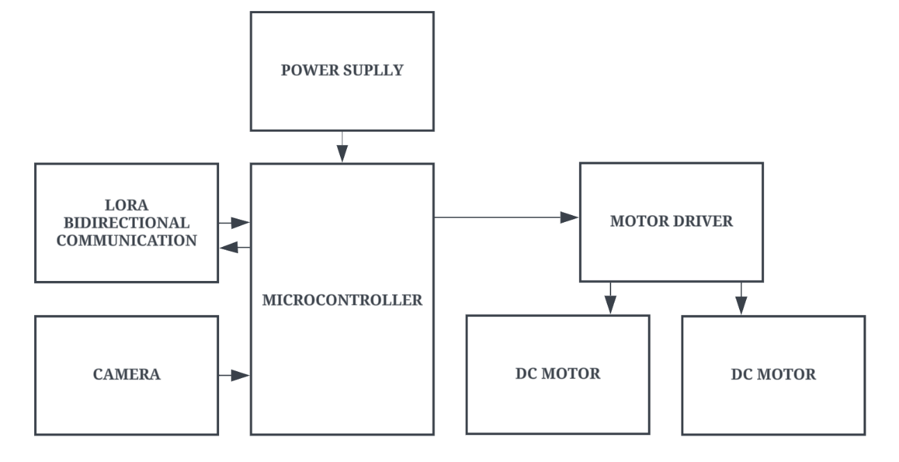

**Figure 7.3: Block Diagram of Rover Side**

Using a website or android application, the farmers can remotely control the motor. Here system receiver work as a transmitter. Now our transmitter is a collection of ESP32, LoRa SX1278 with antenna, 5V power supply, and controlling web page.



**Figure 7.4: Block Diagram of processing side**

* + 1. **Neuro-Driven Control System**

The Neuro-Driven Control System module harnesses the power of Brain-Computer Interface (BCI) technology to enable direct control of the robot's movements and actions through neural signals. This innovative system translates brain activity captured by BCI sensors into actionable commands for the robot, facilitating intuitive and responsive control.

**Neural Signal Acquisition:**

The module begins with the acquisition of neural signals using BCI sensors, such as electroencephalography (EEG) electrodes or other neuroimaging devices. These sensors detect electrical signals generated by the user's brain activity, capturing patterns associated with specific cognitive states or commands.

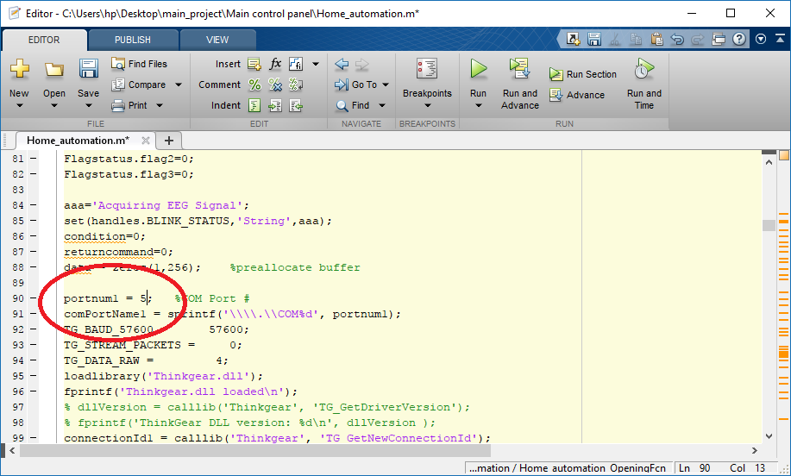**Figure 7.5: Matlab interface**

**Signal Processing and Interpretation:**

Once neural signals are acquired, they undergo signal processing and interpretation using advanced algorithms, often implemented in MATLAB or other signal processing software. These algorithms analyze the neural data to extract relevant features or patterns indicative of the user's intent or commands.

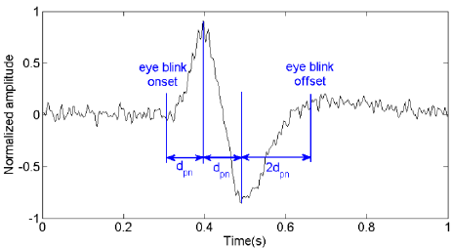

**Figure 7.6: Signal Filtering**

**Command Generation and Transmission:**

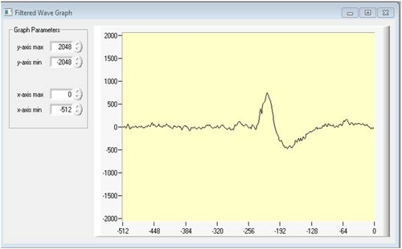Based on the processed neural data, the Neuro-Driven Control System generates corresponding control commands for the robot. These commands may include instructions for movement, navigation, task execution, or interaction with the environment. The generated commands are then transmitted to the robot's control system, enabling it to execute the desired actions in real-time.

**Figure 7.7: Signal Mapping**

By integrating a Neuro-Driven Control System into the robot's architecture, users can interact with the robot directly through their brain activity, bypassing traditional input devices like joysticks or keyboards. This not only enhances the user experience by providing a more intuitive control interface but also opens up possibilities for applications in assistive robotics, neurorehabilitation, and human-robot collaboration. However, challenges such as signal noise, calibration, and user training must be addressed to ensure reliable and accurate control performance.

* + 1. **Real-Time Video Streaming**

The Real-Time Video Streaming module utilizes the ESP32-CAM to transmit live video feed from the robot's integrated camera to a remote monitoring station in real-time. This module encompasses several key functionalities:

The ESP32-CAM captures video footage using its onboard camera module and encodes the video stream into a suitable format for transmission over the communication network. Encoding formats like MJPEG or H.264 are typically employed to balance video quality and bandwidth consumption.

Once encoded, the module selects an appropriate transmission protocol, such as RTSP, RTP, or HTTP, based on factors like latency requirements, network bandwidth, and compatibility with the receiving end.

The encoded video stream is then transmitted over the communication network in real-time. The ESP32-CAM can utilize Wi-Fi for wireless communication indoors or pair with external modules like LoRa or GSM for long-range communication in outdoor or remote environments.

At the receiving end, a remote monitoring interface displays the live video feed, allowing operators to observe the robot's surroundings and activities remotely.

Utilizing the ESP32-CAM for real-time video streaming offers a cost-effective and compact solution for integrating visual feedback into robotic applications. However, challenges such as managing latency, optimizing bandwidth usage, and ensuring robust network connectivity need to be addressed for reliable performance.

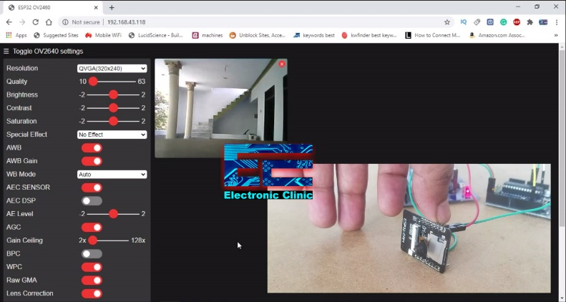

**Figure 7.8: Live Streaming**

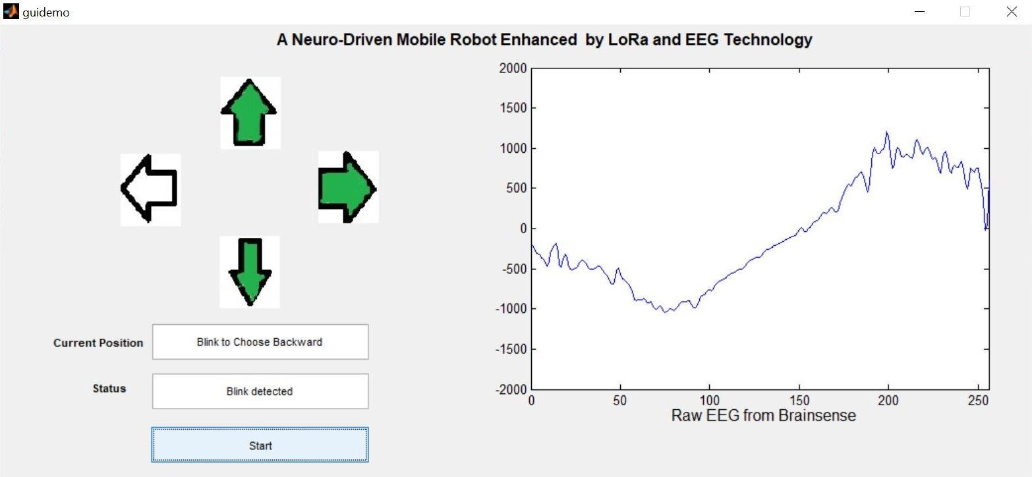**Figure 7.9: Matlab Signal Processed Interface**

**CHAPTER 8**

**SYSTEM TESTING**

The purpose of testing is to discover errors. Testing is the process of trying to discover every conceivable fault or weakness in a work product. It provides a way to check the functionality of components, sub-assemblies, assemblies and/or a finished product It is the process of exercising software with the intent of ensuring that the Software system meets its requirements and user expectations and does not fail in an unacceptable manner. There are various types of tests. Each test type addresses a specific testing requirement.

# TYPES OF TESTS

## Unit testing

Unit testing involves the design of test cases that validate that the internal program logic is functioning properly, and that program inputs produce valid outputs. All decision branches and internal code flow should be validated. It is the testing of individual software units of the application it is done after the completion of an individual unit before integration. This is a structural testing, that relies on knowledge of its construction and is invasive. Unit tests perform basic tests at component level and test a specific business process, application, and/or system configuration. Unit tests ensure that each unique path of a business process performs accurately to the documented specifications and contains clearly defined inputs and expected results.

## Integration testing

Integration tests are designed to test integrated software components to determine if they actually run as one program. Testing is event driven and is more I concerned with the basic outcome of screens or fields. Integration tests demonstrate that although the components were individually satisfaction, as shown by successfully unit testing, the combination of components is correct and consistent. Integration testing is specifically aimed at exposing the problems that arise from the combination of components.

## Functional test

Functional tests provide systematic demonstrations that functions tested are available as specified by the business and technical requirements, system documentation, and user manuals.

**Functional testing is centered on the following items:**

Valid Input: identified classes of valid input must be accepted. Invalid Input: identified classes of invalid input must be rejected.

Functions: identified functions must be exercised.

Output: identified classes of application outputs must be exercised. Procedure: interfacing systems or procedures must be invoked.

Organization and preparation of functional tests is focused on requirements, key functions, or special test cases. In addition, systematic coverage pertaining to identify Business process flows; data fields, predefined processes, and successive processes must be considered for testing. Before functional testing is complete. additional tests are identified and the effective value of current tests is determined.

## System Test

System testing ensures that the entire integrated software system meets requirements. It tests a configuration to ensure known and predictable results. An example of system testing is the configuration-oriented system integration test. System testing is based on process descriptions and flows, emphasizing pre-driven process links and integration points.

## White Box Testing

White Box Testing is a testing in which in which the software tester has knowledge of the inner workings, structure and language of the software, or at least as purpose. It is purpose. It is used to test areas that cannot be reached from a black box level.

## Black Box Testing

Black Box Testing is testing the software without any knowledge of the inner workings, structure or language of the module being, tested. Black box tests, as most other kinds of tests, must be written from a definitive source document, such as specification or requirements document, such as specification or requirements document. It is a testing in which the software under test is treated, as a black box you cannot "see" into it. The test provides inputs and responds to outputs without considering how the software works:

# UNIT TESTING

Unit testing is usually conducted as part of a combined code and unit test phase of the software lifecycle, although it is not uncommon for coding and unit testing to be conducted as two distinct phases.

## Test strategy and approach

Field testing will be performed manually and functional tests will be written in detail.

## Test objectives

* + - * All field entries must work properly.
      * Pages must be activated from the identified link.
      * The entry screen, messages and responses must not be delayed.

## Features to be tested

* + - * Verify that the entries are of the correct format
      * No duplicate entries should be allowed
      * All links should take the user to the correct page.

# INTEGRATION TESTING

Software integration testing is the incremental integration testing of two of more integrated software components on a single platform to produce failures caused by interface defects.

The task of the integration test is to check that components or software applications, e.g. components in a software system or - one step up – software applications at the company level

- interact without error.

**Test Results:** All the test cases mentioned above passed successfully. No defects encountered.

# ACCEPTANCE TESTING

User Acceptance Testing is a critical phase of any project and requires significant participation by the end user. It also ensures that the system meets the functional requirements. Test Results: All the test cases mentioned above passed successfully. No defects encountered.

**CHAPTER 9**

**CONCLUSION AND FUTURE ENHANCEMENT**

* 1. **CONCLUSION**
* In conclusion, the project represents a significant advancement in the integration of cognitive science, robotics, and communication technology. By harnessing EEG signals through a Brain-Computer Interface (BCI) and leveraging LoRa communication for long-range connectivity, the system enables intuitive human-robot interaction and remote control.
* The successful implementation of this project opens doors to diverse applications in fields such as exploration, surveillance, and assistance, showcasing the potential for transformative advancements in human-robot interaction paradigms.
  1. **FUTURE ENHANCEMENT**
* In future, planned to make this as an application which can be easily used by everyone.
* Implementing advanced machine learning algorithms to enable the rover to continuously learn from its interactions and improve its cognitive capabilities over time.
* Integrating additional sensors to broaden the rover's sensory capabilities, enabling it to gather more comprehensive data about its environment and make more informed decisions.
* Developing intuitive interfaces that simplify interaction with the rover, making it easier for operators to control and collaborate with the system, ultimately enhancing its usability and effectiveness.

**CHAPTER 10**

**APPENDICES**

**APPENDIX I**

**SOURCE CODE**

***Processing_Side.ino***

#include<SPI.h>

#include<LoRa.h>

#define SS D8

#define RST D0

#define DIO0 D1

String dat1;

char dat;

void setup()

{

Serial.begin(9600);

while (!Serial);

LoRa.setPins(SS,RST,DIO0);

Serial.println("LORA SENDER");

if (!LoRa.begin(433E6))

{

Serial.println("STARTING LORA FAILED");

while(1);

}

}

void loop()

{

if(Serial.available())

{

dat = Serial.read();

Serial.println(dat);

if(dat == 'F')

{

String dat1 = String ("A")+":"+String("");

LoRa.beginPacket();

LoRa.println(dat1);

Serial.println(dat1);

LoRa.endPacket();

delay(1000);

}

else if (dat == 'B')

{

String dat1 = String ("")+":"+String("B");

LoRa.beginPacket();

LoRa.println(dat1);

Serial.println(dat1);

LoRa.endPacket();

delay(1000);

}

else if (dat == 'R')

{

String dat1 = String ("")+":"+String("")+":"+String("C");

LoRa.beginPacket();

LoRa.println(dat1);

Serial.println(dat1);

LoRa.endPacket();

delay(1000);

}

else if (dat == 'L')

{

String dat1 = String ("")+":"+String("")+":"+String("")+":"+String("D");

LoRa.beginPacket();

LoRa.println(dat1);

Serial.println(dat1);

LoRa.endPacket();

delay(1000);

}

else if (dat == 'S')

{

String dat1 = String ("")+":"+String("")+":"+String("")+":"+String("")+":"+String("E");

LoRa.beginPacket();

LoRa.println(dat1);

Serial.println(dat1);

LoRa.endPacket();

delay(1000);

}

}

}

***Rover_Side.ino***

#include<SPI.h>

#include<LoRa.h>

#define SS D8

#define RST D0

#define DIO0 D1

int m1 = D2;

int m2 = D3;

int m3 = D4;

int m4 = 3;

String a,b,c,d,e;

String getStringPartByNr(String data, char separator, int index)

{

int stringdata = 0;

String datapart ="";

for (int i=0; i<data.length()-1; i++)

{

if(data[i]==separator)

{

stringdata++;

}

else if (stringdata== index)

{

datapart.concat(data[i]);

}

else if (stringdata>index)

{

return datapart;

break;

}

}

return datapart;

}

void setup()

{

Serial.begin(9600);

pinMode(m1,OUTPUT);

pinMode(m2,OUTPUT);

pinMode(m3,OUTPUT);

pinMode(m4,OUTPUT);

while(!Serial)

Serial.println("LORA RECEIVER");

LoRa.setPins(SS, RST, DIO0);

if(!LoRa.begin(433E6))

{

Serial.println("STATRING LORA RECIEVED FAILED");

while(1);

}

}

void loop()

{

int packetsize = LoRa.parsePacket();

if (packetsize)

{

Serial.print("RECEIVED PACKET");

while(LoRa.available())

{

String rcv = LoRa.readStringUntil('\n');

Serial.println(rcv);

String a= getStringPartByNr(rcv,':',0);

String b= getStringPartByNr(rcv,':',1);

String c= getStringPartByNr(rcv,':',2);

String d= getStringPartByNr(rcv,':',3);

String e= getStringPartByNr(rcv,':',4);

Serial.println("FORWARD="+String(a));

Serial.println("BACKWARD="+String(b));

if(a == "F")

{

Serial.println("ROBOT MOVING FORWARD");

digitalWrite(m1,HIGH);

digitalWrite(m2,LOW);

digitalWrite(m3,HIGH);

digitalWrite(m4,LOW);

}

else if(b == "B")

{

Serial.println("ROBOT MOVING BACKWARD");

digitalWrite(m1,LOW);

digitalWrite(m2,HIGH);

digitalWrite(m3,LOW);

digitalWrite(m4,HIGH);

}

else if(c == "R")

{

Serial.println("ROBOT MOVING RIGHT");

digitalWrite(m1,HIGH);

digitalWrite(m2,LOW);

digitalWrite(m3,LOW);

digitalWrite(m4,HIGH);

}

else if(d == "L")

{

Serial.println("ROBOT MOVING LEFT");

digitalWrite(m1,LOW);

digitalWrite(m2,HIGH);

digitalWrite(m3,HIGH);

digitalWrite(m4,LOW);

}

else if(e == "S")

{

Serial.println("ROBOT MOVING STOP");

digitalWrite(m1,LOW);

digitalWrite(m2,LOW);

digitalWrite(m3,LOW);

digitalWrite(m4,LOW);

}

}

}

}

***Guidemo.m***

function varargout = guidemo(varargin)

gui_Singleton = 1;

gui_State = struct('gui_Name', mfilename, ...

'gui_Singleton', gui_Singleton, ...

'gui_OpeningFcn', @guidemo_OpeningFcn, ...

'gui_OutputFcn', @guidemo_OutputFcn, ...

'gui_LayoutFcn', [] , ...

'gui_Callback', []);

if nargin && ischar(varargin{1})

gui_State.gui_Callback = str2func(varargin{1});

end

if nargout

[varargout{1:nargout}] = gui_mainfcn(gui_State, varargin{:});

else

gui_mainfcn(gui_State, varargin{:});

end

function guidemo_OpeningFcn(hObject, eventdata, handles, varargin)

handles.output = hObject;

aaa='Wait till initialization completes';

set(handles.edit1,'String',aaa);

a=imread('left.jpg');

axes(handles.axes4);

imshow(a);

b=imread('right.jpg');

axes(handles.axes2);

imshow(b);

c=imread('forward.jpg');

axes(handles.axes1);

imshow(c);

d=imread('backward.jpg');

axes(handles.axes3);

imshow(d);

instrhwinfo('Bluetooth','HC-05');

bt = Bluetooth('HC-05', 1);

fopen(bt)

handles.bt=bt;

aaa='Initialization Completes ,Press Start';

set(handles.edit1,'String',aaa);

guidata(hObject, handles);

function varargout = guidemo_OutputFcn(hObject, eventdata, handles)

varargout{1} = handles.output;

function edit1_Callback(hObject, eventdata, handles)

function edit1_CreateFcn(hObject, eventdata, handles)

if ispc && isequal(get(hObject,'BackgroundColor'), get(0,'defaultUicontrolBackgroundColor'))

set(hObject,'BackgroundColor','white');

end

function edit3_Callback(hObject, eventdata, handles)

function edit3_CreateFcn(hObject, eventdata, handles)

if ispc && isequal(get(hObject,'BackgroundColor'), get(0,'defaultUicontrolBackgroundColor'))

set(hObject,'BackgroundColor','white');

end

function Start_Callback(hObject, eventdata, handles)

bt=handles.bt;

aaa='Acquiring EEG Signal';

set(handles.edit1,'String',aaa);

condition=0;

returncommand=0;

data = zeros(1,256); %preallocate buffer

portnum1 = 5; %COM Port #

comPortName1 = sprintf('\\\\.\\COM%d', portnum1);

TG_BAUD_57600 = 9600;

TG_STREAM_PACKETS = 0;

TG_DATA_RAW = 4;

loadlibrary('Thinkgear.dll');

fprintf('Thinkgear.dll loaded\n');

dllVersion = calllib('Thinkgear', 'TG_GetDriverVersion');

fprintf('ThinkGear DLL version: %d\n', dllVersion );

connectionId1 = calllib('Thinkgear', 'TG_GetNewConnectionId');

if ( connectionId1 < 0 )

error( sprintf( 'ERROR: TG_GetNewConnectionId() returned %d.\n', connectionId1 ) );

end;

i=0;

while i< 3

currentpos=3;

c=imread('forwardc.jpg');

axes(handles.axes1);

imshow(c);

aa='Blink to Choose Forward';

bb='No Blinks Detected'

set(handles.edit3,'String',bb);

set(handles.edit1,'String',aa);

pause(1);

readblink(bt,connectionId1,comPortName1,TG_BAUD_57600,TG_STREAM_PACKETS,TG_DATA_RAW,hObject, eventdata, handles,currentpos);

currentpos=2;

b=imread('rightc.jpg');

axes(handles.axes2);

imshow(b);

aa='Blink to Choose Right';

set(handles.edit1,'String',aa);

bb='No Blinks Detected'

set(handles.edit3,'String',bb);

pause(1);

readblink(bt,connectionId1,comPortName1,TG_BAUD_57600,TG_STREAM_PACKETS,TG_DATA_RAW,hObject, eventdata, handles,currentpos);

currentpos=4;

d=imread('backwardc.jpg');

axes(handles.axes3);

imshow(d);

aa='Blink to Choose Backward';

set(handles.edit1,'String',aa);

bb='No Blinks Detected'

set(handles.edit3,'String',bb);

pause(1);

readblink(bt,connectionId1,comPortName1,TG_BAUD_57600,TG_STREAM_PACKETS,TG_DATA_RAW,hObject, eventdata, handles,currentpos);

currentpos=1;

a=imread('leftc.jpg');

axes(handles.axes4);

imshow(a);

aa='Blink to Choose Left';

set(handles.edit1,'String',aa);

bb='No Blinks Detected'

set(handles.edit3,'String',bb);

pause(1);

readblink(bt,connectionId1,comPortName1,TG_BAUD_57600,TG_STREAM_PACKETS,TG_DATA_RAW,hObject, eventdata, handles,currentpos);

a=imread('left.jpg');

axes(handles.axes4);

imshow(a);

b=imread('right.jpg');

axes(handles.axes2);

imshow(b);

c=imread('forward.jpg');

axes(handles.axes1);

imshow(c);

d=imread('backward.jpg');

axes(handles.axes3);

imshow(d);

i=i+1;

end

fwrite(bt,'S');

aaa='Press Start to Restart';

set(handles.edit1,'String',aaa);

function_readblink(bt,connectionId1,comPortName1,TG_BAUD_57600,TG_STREAM_PACKETS,TG_DATA_RAW,hObject, eventdata, handles,currentpos)

connectionId1 = calllib('Thinkgear', 'TG_GetNewConnectionId');

if ( connectionId1 < 0 )

error( sprintf( 'ERROR: TG_GetNewConnectionId() returned %d.\n', connectionId1 ) );

end;

errCode = calllib('Thinkgear', 'TG_Connect', connectionId1,comPortName1,TG_BAUD_57600,TG_STREAM_PACKETS );

if ( errCode < 0 )

error( sprintf( 'ERROR: TG_Connect() returned %d.\n', errCode ) );

end

fprintf( 'Connected. detecting blinks...\n' );

bb='Ready to capture Blinks'

set(handles.edit3,'String',bb);

j = 0;

i = 0;

while (i < 4240) %loop for 20 seconds

if (calllib('Thinkgear','TG_ReadPackets',connectionId1,1) == 1) %if a packet was read...

j = j + 1;

i = i + 1;

data(j) = calllib('Thinkgear','TG_GetValue',connectionId1,TG_DATA_RAW);

end

if (j == 256)

axes(handles.axes6);

plotRAW(data); %plot the data, update every .5 seconds (256 points)

out=max(data);

out1=min(data);

if ((out > 800) && (out1 < -800))

amp=5

fs=1000 % sampling frequency

duration=1

freq=100

values=0:1/fs:duration;

a=amp*sin(2*pi* freq*values)

sound(a)

aa='Blink detected';

switch currentpos

case 1

a=imread('lefts.jpg');

axes(handles.axes4);

imshow(a);

fwrite(bt,'L');

pause(1);

case 2

b=imread('rights.jpg');

axes(handles.axes2);

imshow(b);

fwrite(bt,'R');

pause(1);

case 3

c=imread('forwards.jpg');

axes(handles.axes1);

imshow(c);

fwrite(bt,'F');

pause(1);

case 4

d=imread('backwards.jpg');

axes(handles.axes3);

imshow(d);

fwrite(bt,'B');

pause(1);

end

set(handles.edit3,'String',aa);

pause(1);

break

end

j = 0;

end

end

calllib('Thinkgear', 'TG_FreeConnection', connectionId1 );

***Video-Streaming.ino***

#include "esp_camera.h"

#include <WiFi.h>

#include "esp_timer.h"

#include "img_converters.h"

#include "Arduino.h"

#include "fb_gfx.h"

#include "soc/soc.h" //disable brownout problems

#include "soc/rtc_cntl_reg.h" //disable brownout problems

#include "esp_http_server.h"

const char* ssid = "Akash";

const char* password = "1234567890";

#define PART_BOUNDARY "123456789000000000000987654321"

#define CAMERA_MODEL_AI_THINKER

#if defined(CAMERA_MODEL_WROVER_KIT)

#define PWDN_GPIO_NUM -1

#define RESET_GPIO_NUM -1

#define XCLK_GPIO_NUM 21

#define SIOD_GPIO_NUM 26

#define SIOC_GPIO_NUM 27

#define Y9_GPIO_NUM 35

#define Y8_GPIO_NUM 34

#define Y7_GPIO_NUM 39

#define Y6_GPIO_NUM 36

#define Y5_GPIO_NUM 19

#define Y4_GPIO_NUM 18

#define Y3_GPIO_NUM 5

#define Y2_GPIO_NUM 4

#define VSYNC_GPIO_NUM 25

#define HREF_GPIO_NUM 23

#define PCLK_GPIO_NUM 22

#elif defined(CAMERA_MODEL_M5STACK_PSRAM)

#define PWDN_GPIO_NUM -1

#define RESET_GPIO_NUM 15

#define XCLK_GPIO_NUM 27

#define SIOD_GPIO_NUM 25

#define SIOC_GPIO_NUM 23

#define Y9_GPIO_NUM 19

#define Y8_GPIO_NUM 36

#define Y7_GPIO_NUM 18

#define Y6_GPIO_NUM 39

#define Y5_GPIO_NUM 5

#define Y4_GPIO_NUM 34

#define Y3_GPIO_NUM 35

#define Y2_GPIO_NUM 32

#define VSYNC_GPIO_NUM 22

#define HREF_GPIO_NUM 26

#define PCLK_GPIO_NUM 21

#elif defined(CAMERA_MODEL_M5STACK_WITHOUT_PSRAM)

#define PWDN_GPIO_NUM -1

#define RESET_GPIO_NUM 15

#define XCLK_GPIO_NUM 27

#define SIOD_GPIO_NUM 25

#define SIOC_GPIO_NUM 23

#define Y9_GPIO_NUM 19

#define Y8_GPIO_NUM 36

#define Y7_GPIO_NUM 18

#define Y6_GPIO_NUM 39

#define Y5_GPIO_NUM 5

#define Y4_GPIO_NUM 34

#define Y3_GPIO_NUM 35

#define Y2_GPIO_NUM 17

#define VSYNC_GPIO_NUM 22

#define HREF_GPIO_NUM 26

#define PCLK_GPIO_NUM 21

#elif defined(CAMERA_MODEL_AI_THINKER)

#define PWDN_GPIO_NUM 32

#define RESET_GPIO_NUM -1

#define XCLK_GPIO_NUM 0

#define SIOD_GPIO_NUM 26

#define SIOC_GPIO_NUM 27

#define Y9_GPIO_NUM 35

#define Y8_GPIO_NUM 34

#define Y7_GPIO_NUM 39

#define Y6_GPIO_NUM 36

#define Y5_GPIO_NUM 21

#define Y4_GPIO_NUM 19

#define Y3_GPIO_NUM 18

#define Y2_GPIO_NUM 5

#define VSYNC_GPIO_NUM 25

#define HREF_GPIO_NUM 23

#define PCLK_GPIO_NUM 22

#else

#error "Camera model not selected"

#endif

static const char* _STREAM_CONTENT_TYPE = "multipart/x-mixed-replace;boundary=" PART_BOUNDARY;

static const char* _STREAM_BOUNDARY = "\r\n--" PART_BOUNDARY "\r\n";

static const char* _STREAM_PART = "Content-Type: image/jpeg\r\nContent-Length: %u\r\n\r\n";

httpd_handle_t stream_httpd = NULL;

static esp_err_t stream_handler(httpd_req_t *req){

camera_fb_t * fb = NULL;

esp_err_t res = ESP_OK;

size_t _jpg_buf_len = 0;

uint8_t * _jpg_buf = NULL;

char * part_buf[64];

res = httpd_resp_set_type(req, _STREAM_CONTENT_TYPE);

if(res != ESP_OK){

return res;

}

while(true){

fb = esp_camera_fb_get();

if (!fb) {

Serial.println("Camera capture failed");

res = ESP_FAIL;

} else {

if(fb->width > 400){

if(fb->format != PIXFORMAT_JPEG){

bool jpeg_converted = frame2jpg(fb, 80, &_jpg_buf, &_jpg_buf_len);

esp_camera_fb_return(fb);

fb = NULL;

if(!jpeg_converted){

Serial.println("JPEG compression failed");

res = ESP_FAIL;

}

} else {

_jpg_buf_len = fb->len;

_jpg_buf = fb->buf;

}

}

}

if(res == ESP_OK){

size_t hlen = snprintf((char *)part_buf, 64, _STREAM_PART, _jpg_buf_len);

res = httpd_resp_send_chunk(req, (const char *)part_buf, hlen);

}

if(res == ESP_OK){

res = httpd_resp_send_chunk(req, (const char *)_jpg_buf, _jpg_buf_len);

}

if(res == ESP_OK){

res = httpd_resp_send_chunk(req, _STREAM_BOUNDARY, strlen(_STREAM_BOUNDARY));

}

if(fb){

esp_camera_fb_return(fb);

fb = NULL;

_jpg_buf = NULL;

} else if(_jpg_buf){

free(_jpg_buf);

_jpg_buf = NULL;

}

if(res != ESP_OK){

break;

}

}

return res;

}

void startCameraServer(){

httpd_config_t config = HTTPD_DEFAULT_CONFIG();

config.server_port = 80;

httpd_uri_t index_uri = {

.uri = "/",

.method = HTTP_GET,

.handler = stream_handler,

.user_ctx = NULL

};

if (httpd_start(&stream_httpd, &config) == ESP_OK) {

httpd_register_uri_handler(stream_httpd, &index_uri);

}}

void setup() {

WRITE_PERI_REG(RTC_CNTL_BROWN_OUT_REG, 0); //disable brownout detector

Serial.begin(115200);

Serial.setDebugOutput(false);

camera_config_t config;

config.ledc_channel = LEDC_CHANNEL_0;

config.ledc_timer = LEDC_TIMER_0;

config.pin_d0 = Y2_GPIO_NUM;

config.pin_d1 = Y3_GPIO_NUM;

config.pin_d2 = Y4_GPIO_NUM;

config.pin_d3 = Y5_GPIO_NUM;

config.pin_d4 = Y6_GPIO_NUM;

config.pin_d5 = Y7_GPIO_NUM;

config.pin_d6 = Y8_GPIO_NUM;

config.pin_d7 = Y9_GPIO_NUM;

config.pin_xclk = XCLK_GPIO_NUM;

config.pin_pclk = PCLK_GPIO_NUM;

config.pin_vsync = VSYNC_GPIO_NUM;

config.pin_href = HREF_GPIO_NUM;

config.pin_sscb_sda = SIOD_GPIO_NUM;

config.pin_sscb_scl = SIOC_GPIO_NUM;

config.pin_pwdn = PWDN_GPIO_NUM;

config.pin_reset = RESET_GPIO_NUM;

config.xclk_freq_hz = 20000000;

config.pixel_format = PIXFORMAT_JPEG;

if(psramFound()){

config.frame_size = FRAMESIZE_UXGA;

config.jpeg_quality = 10;

config.fb_count = 2;

} else {

config.frame_size = FRAMESIZE_SVGA;

config.jpeg_quality = 12;

config.fb_count = 1;

}esp_err_t err = esp_camera_init(&config);

if (err != ESP_OK) {

Serial.printf("Camera init failed with error 0x%x", err);

return;

}WiFi.begin(ssid, password);

while (WiFi.status() != WL_CONNECTED) {

delay(500);

Serial.print(".");}

Serial.println("WiFi connected");

Serial.print("Camera Stream Ready! Go to: http://");

Serial.print(WiFi.localIP());

startCameraServer();

}

void loop() {

delay(1);

}

**APPENDIX II**

**SCREEN SHOTS**

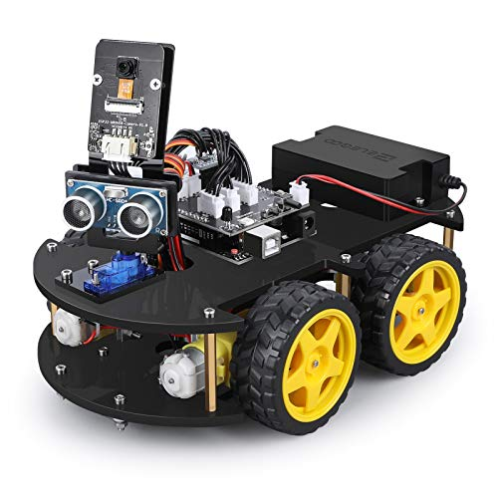**Figure 10.1: Implemented Cognitive Rover**



**Figure 10.2: Matlab Signal Processed Interface**

**Figure 10.3: Signal Mapping**

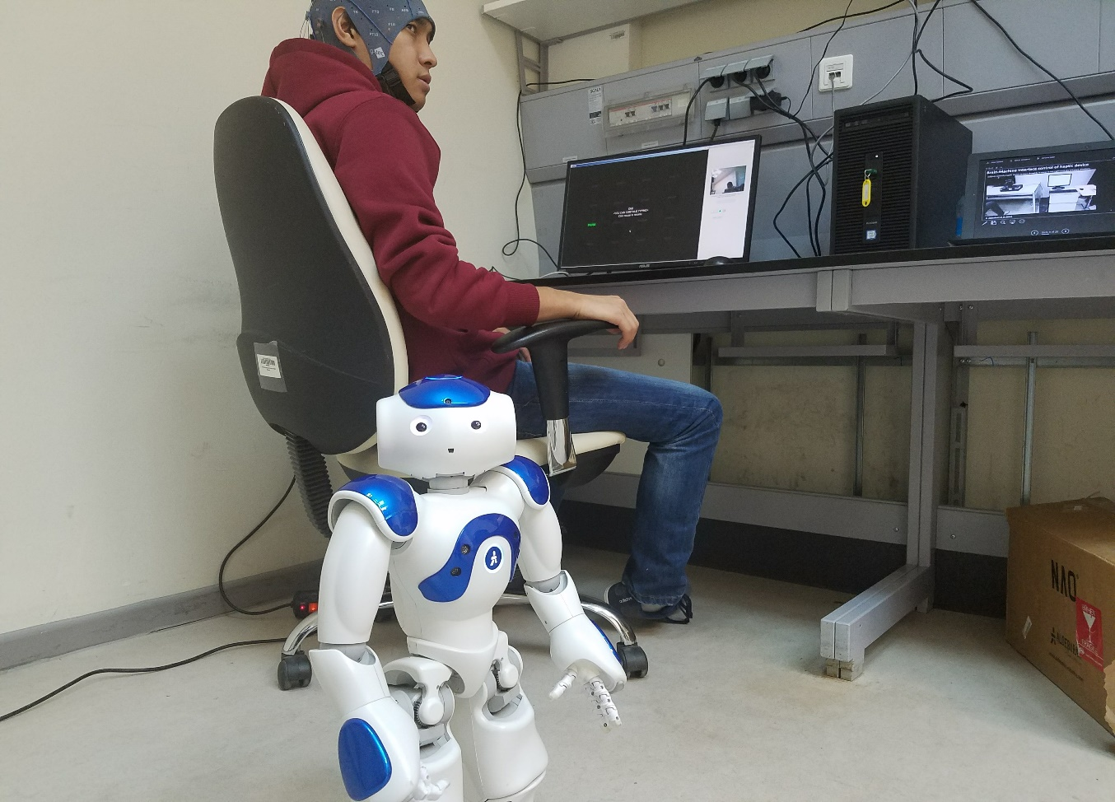

**Figure 10.4: Human Control Rover using Brain-link Headset**

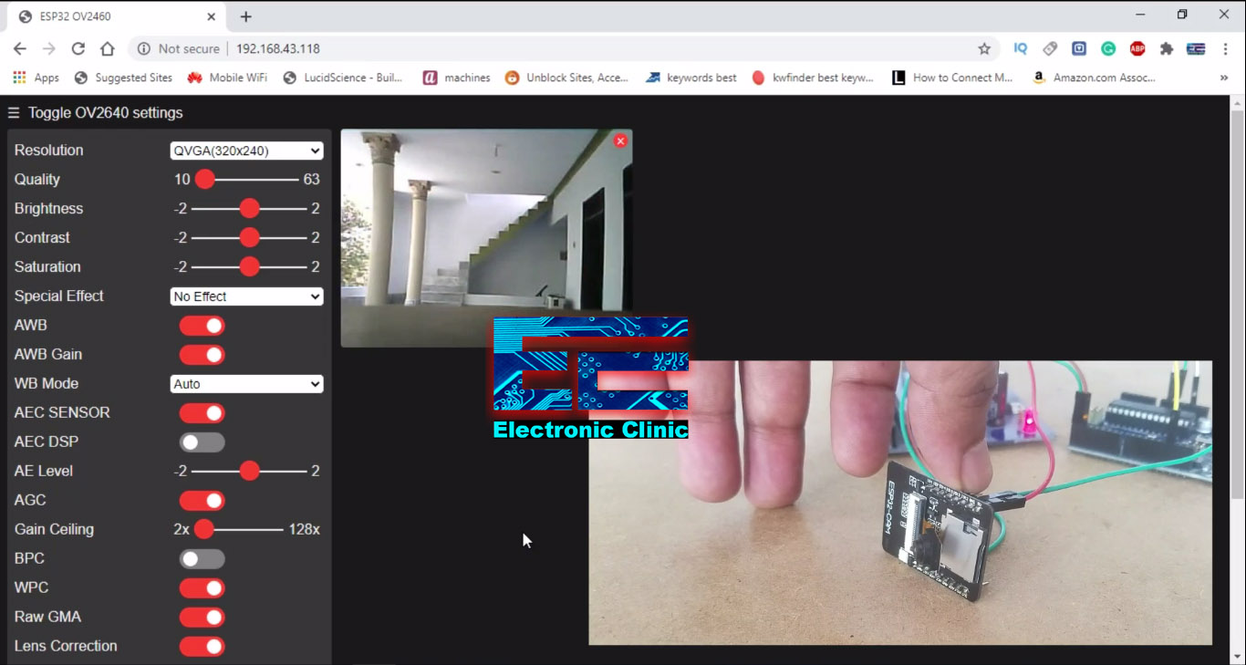**Figure 10.5: Live Streaming**

# REFERENCES

1. X. Gao, D. Xu, M. Cheng, and S. Gao, “A bci-based environmental controller for the motion-disabled,” IEEE Transactions on Neural Systems and Rehabilitation Engineering, vol. 11, pp. 137–140, June 2003.
2. C. Zickler, V. Di Donna, V. Kaiser, A. Al-Khodairy, S. Kleih, A. K¨ubler, M. Malavasi, D. Mattia, S. Mongardi, C. Neuper, et al., “Bci applications for people with disabilities: deﬁning user needs and user requirements,” Assistive technology from adapted equipment to environments, AAATE, vol. 25, pp. 185–189, 2009.
3. S. P. Levine, J. E. Huggins, S. L. BeMent, R. K. Kushwaha, L. A. Schuh, M. M. Rohde, E. A. Passaro, D. A. Ross, K. V. Elisevich, and B. J. Smith, “A direct brain interface based on event-related potentials,” IEEE Transactions on Rehabilitation Engineering, vol. 8, pp. 180–185, Jun 2000.
4. J. J. Vidal, “Real-time detection of brain events in eeg,” Proceedings of the IEEE, vol. 65, pp. 633–641, May 1977.
5. J. J. Daly and J. E. Huggins, “Brain-computer interface: current and emerging rehabilitation applications,” Archives of physical medicine and rehabilitation, vol. 96, no. 3, pp. S1–S7, 2015. Hanggoro, M. A. Putra, R. Reynaldo, and R. F. Sari, “Green-house monitoring and controlling using Android mobile application,” in 2013 International Conference on QiR, Jun. 2013, pp. 79–85, doi: 10.1109/QiR.2013.6632541.
6. Luzheng Bi, Xin-An Fan, Yili Liu “EEG-Based Braincontrolled Mobile Robots: A survey”, Human-Machine Systems, IEEE Transactions on (Volume: 43, Issue: 2), pp. 161-176, Mar 2013.
7. K ale Swapnil T, Mahajan Sadanand P, Rakshe Balu G, Prof. N.K.Bhandari “Robot Navigation control through EEG Based Signals” International Journal Of Engineering And Computer Science ISSN:2319-7242 Issue 3 March-2014.
8. E. W. Sellers, P. Turner, W. A. Sarnacki, T. Mcmanus, T. M. Vaughan, and B. Matthews, “A novel dry electrode for brain–computer interface,” in Proc. 13th Int. Conf. Human–Computer Interac., San Diego, CA, 2009, pp. 623–631.
9. J.d.R.Millan, R.Rupp, G.R.Muller-Putz, R. MurraySmith, C.Giugliemma, M.angermann, C. Vidaurre, F.Cincotti, A.Kubler, R. Leeb, C.Neuper, K.-R. Muller, and D.Mattia, “Combining brain–computer interfaces and assistive technologies state-of-the-art and challenges,” Frontiers Neurosci., vol. 4, pp. 1–15, 2010.
10. Shubh Srivastava, Rajanish Singh. Voice Controlled Robot Car Using Arduino, International Research Journal of Engineering and Technology (IRJET), ISSN: 2395-0056, Volume: 07, Issue: 05, May 2020.

**CONFERENCE CERTIFICATES**

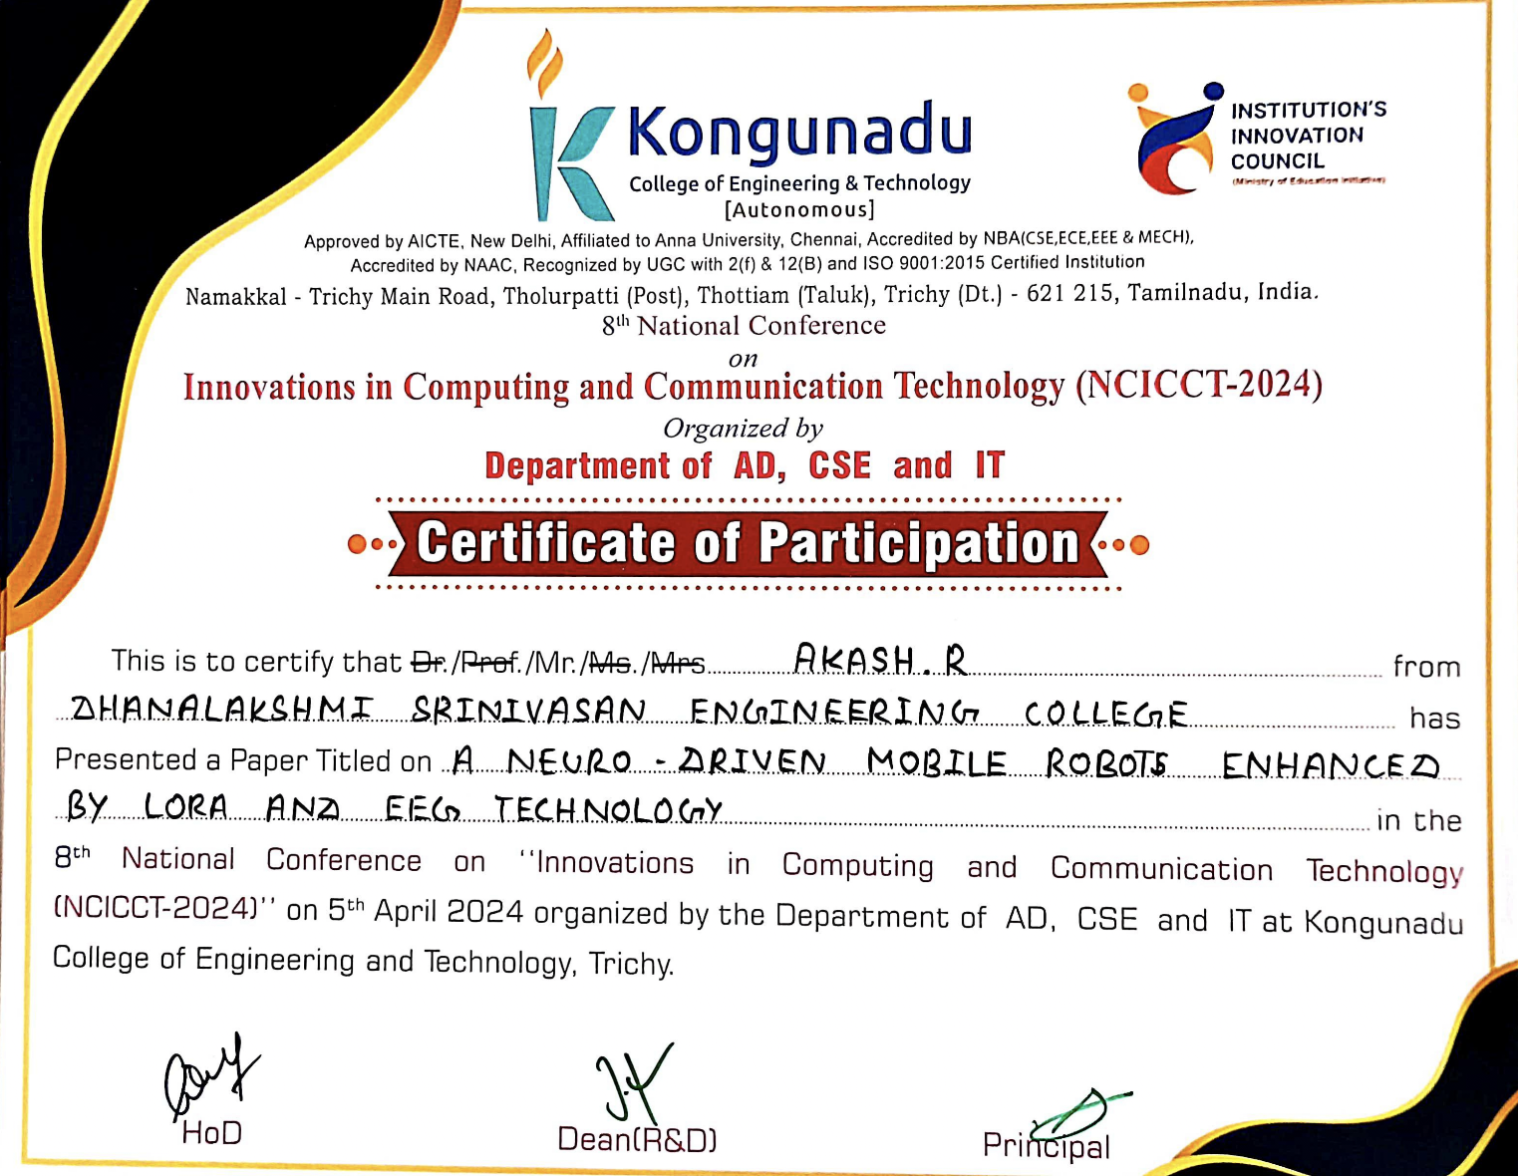

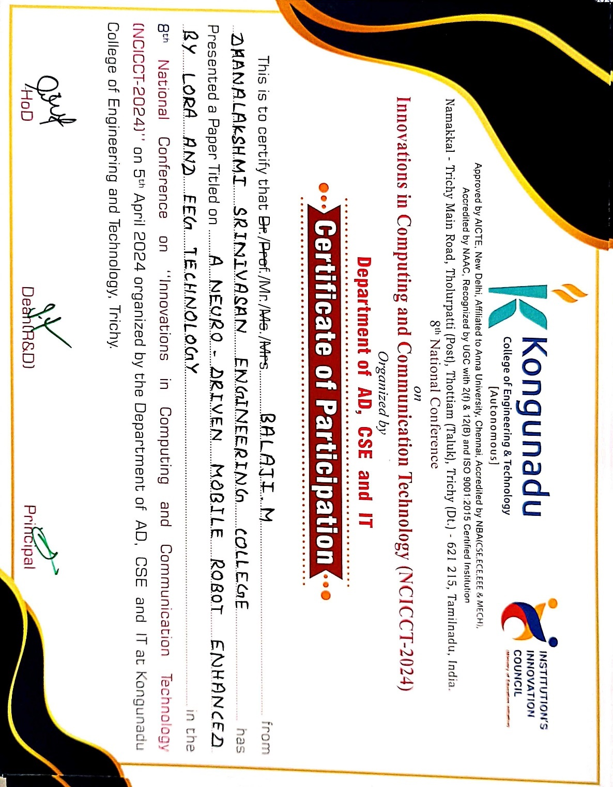

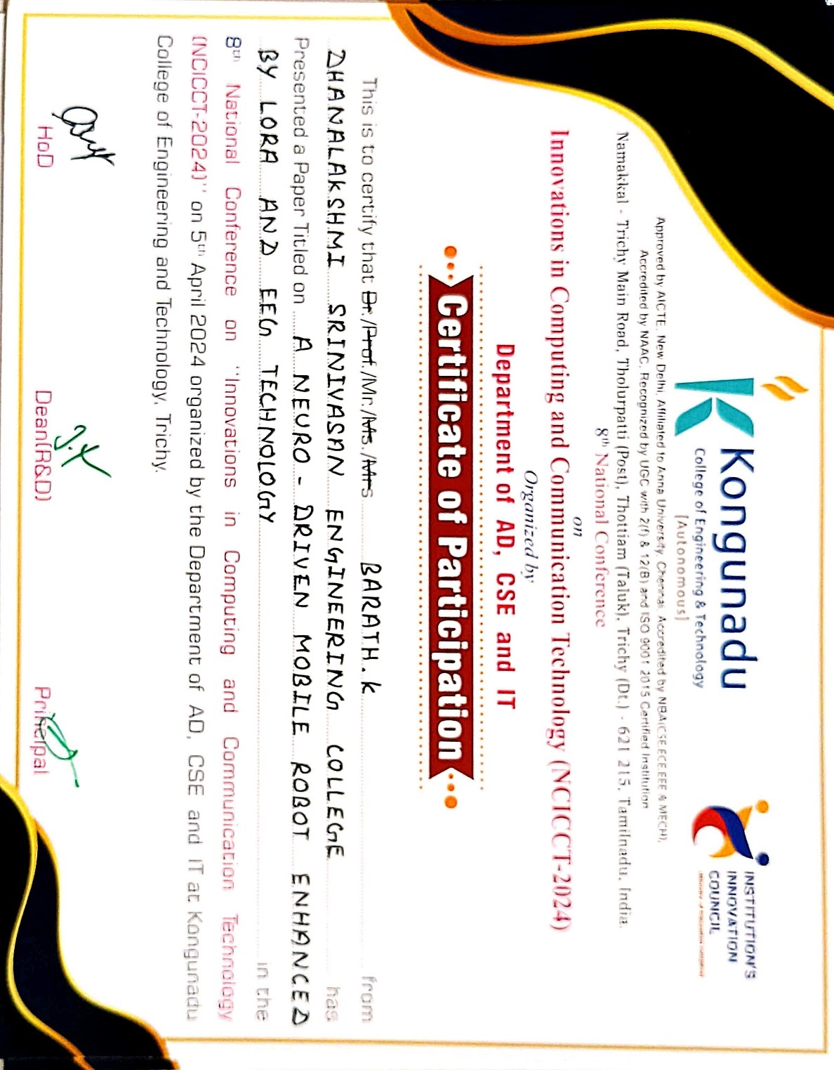

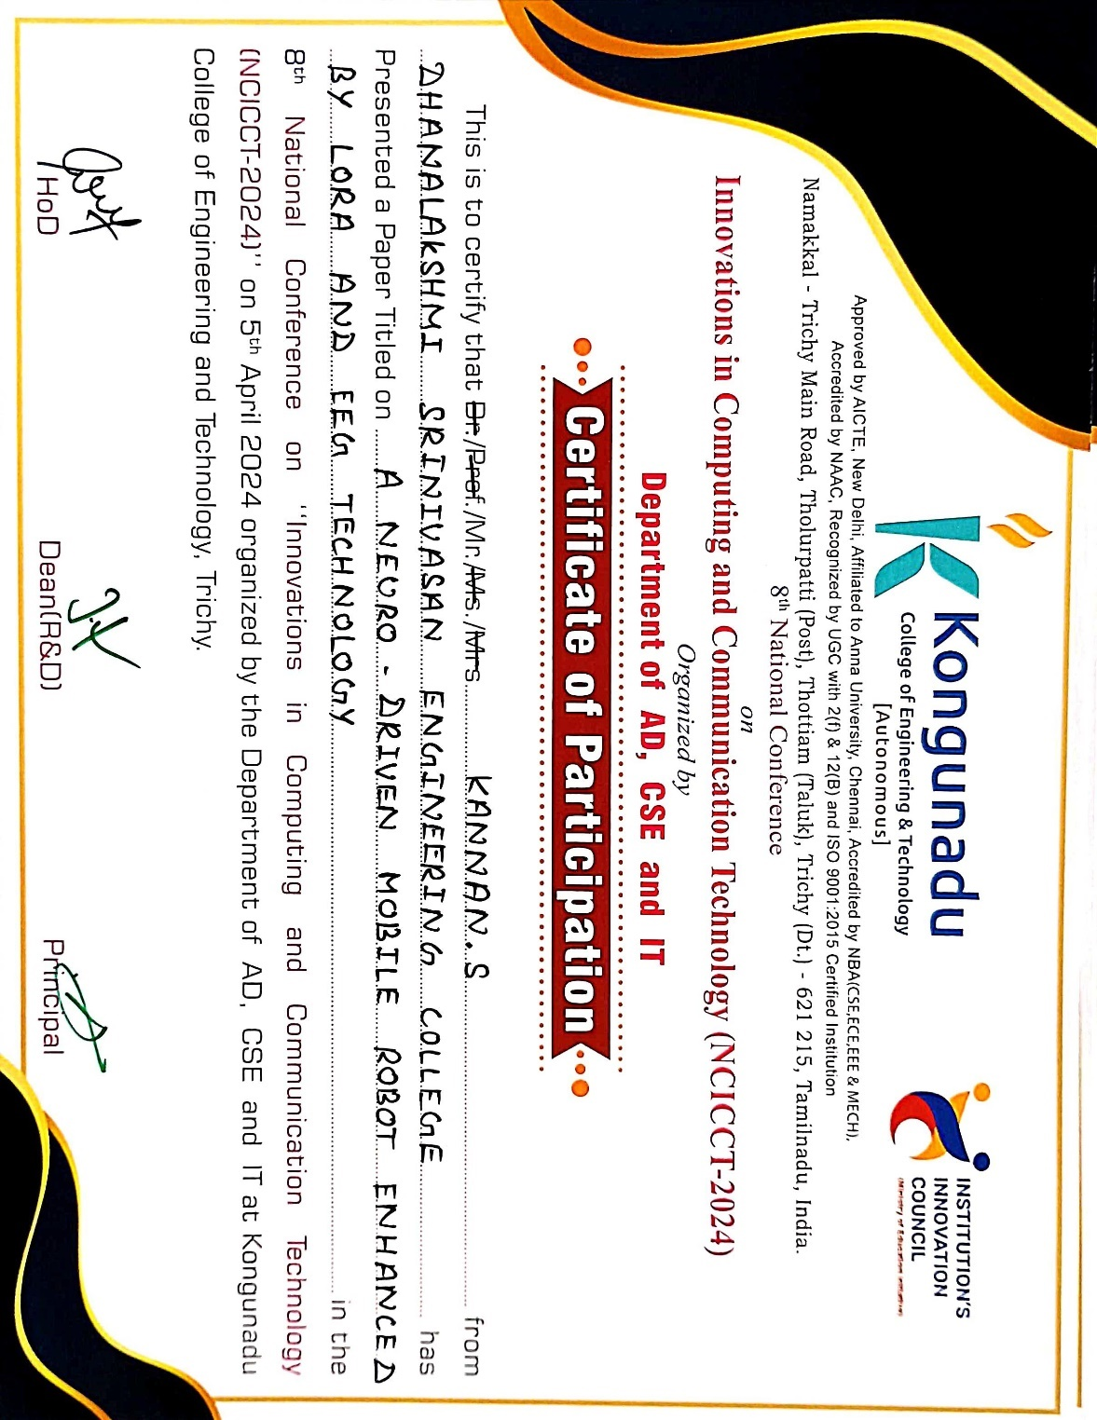

**JOURNAL PUBLICATION**

